**E-R Model – Dimension Model Analysis and Visualizations for Airbnb**

**By Sritha Darbha**

**ER Model for Airbnb**

ER Diagram snapshot for Airbnb:

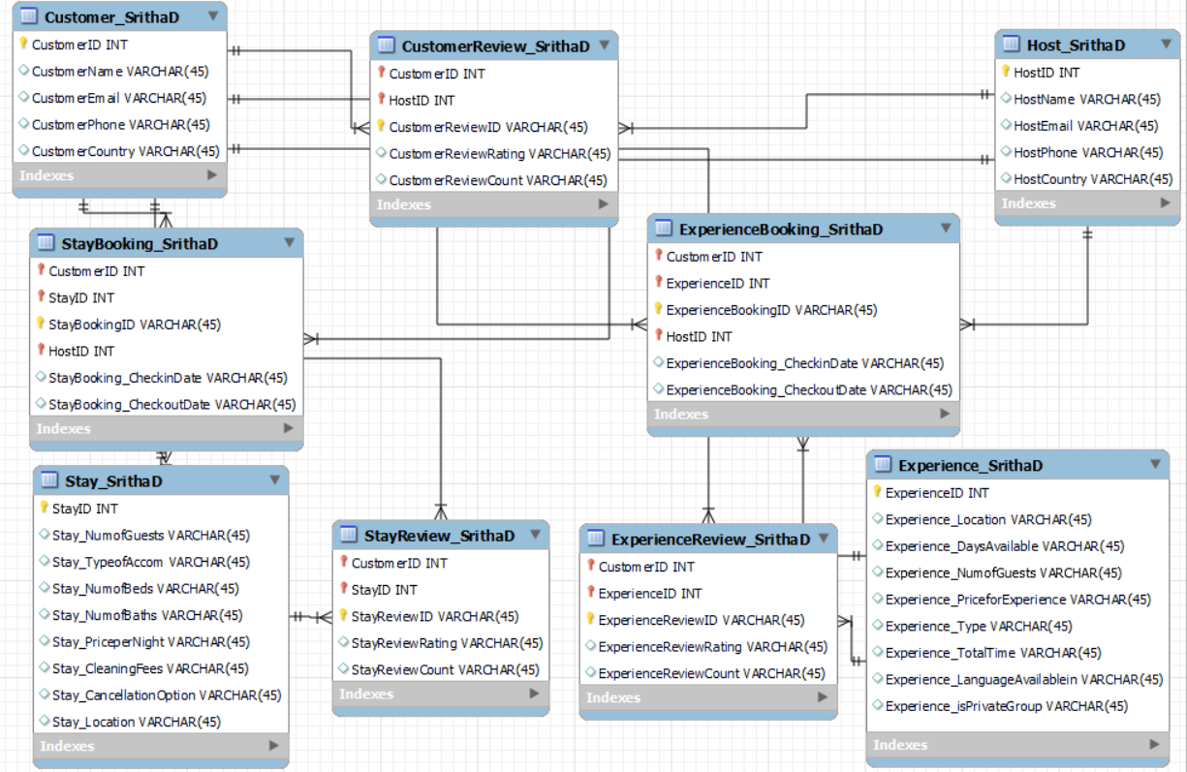

The above E-R Diagram consists of a total of 9 tables out of which 5 tables are Associative/Intersection tables.

The following are the table names:

1.Customer_SrithaD

2.Host_SrithaD

3.Stay_SrithaD

4.Experience_SrithaD

5.StayBooking_SrithaD

6.ExperienceBooking_SrithaD

7.CustomerReview_SrithaD

8.StayReview_SrithaD

9.ExperienceReview_SrithaD

More details about the tables are shown below:

**Table 1: Customer_SrithaD**

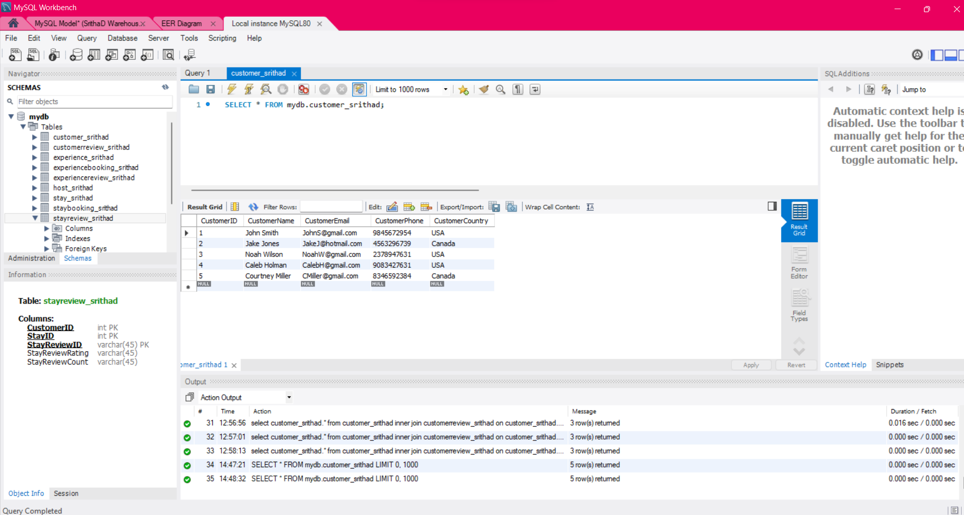

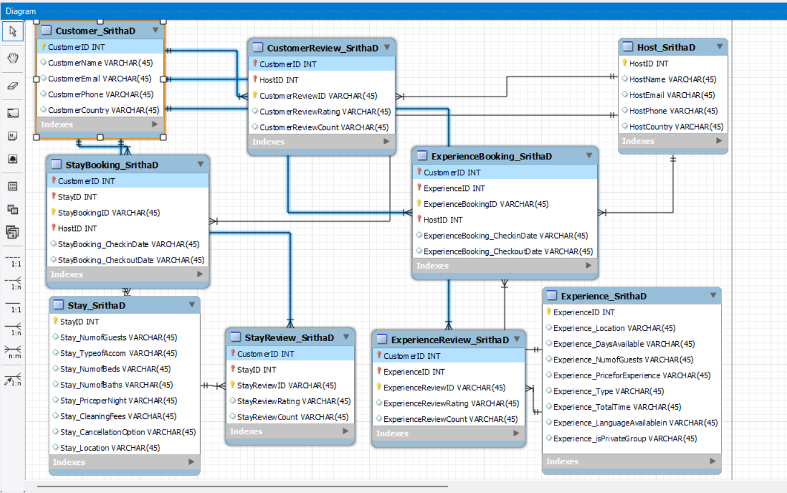

CustomerID is the Primary Key in this table. There are no Foreign Keys. This table has 5 entities and 5 attributes.

This table has relations with CustomerReview_SrithaD, StayBooking_SrithaD, StayReview_SrithaD, ExperienceReview_SrithaD, ExperienceBooking_SrithaD tables.

**Table 2:** **Host_SrithaD**

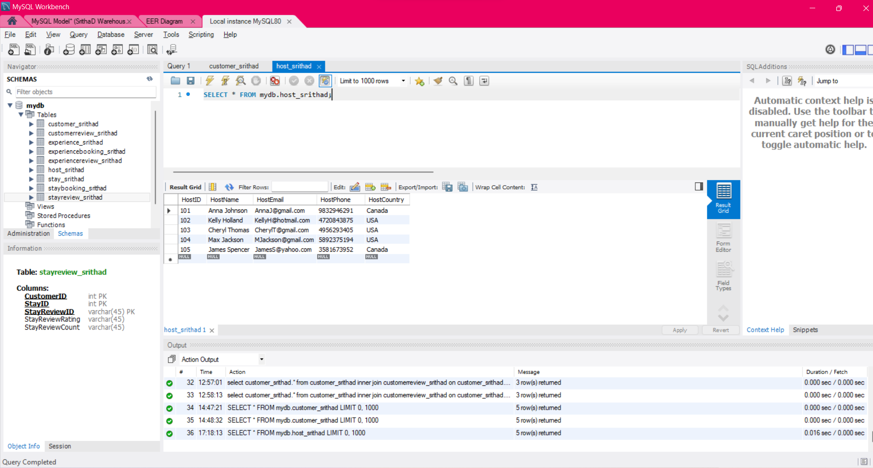

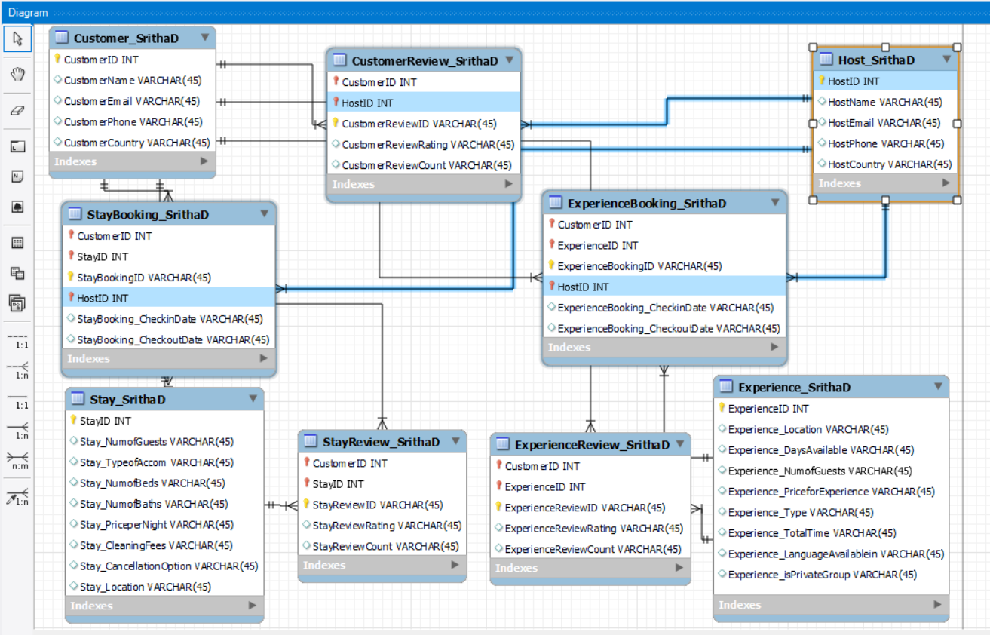

HostID is the Primary Key in this table. There are no Foreign Keys. This table has 5 entities and 5 attributes.

This table has relations with CustomerReview_SrithaD, StayBooking_SrithaD, ExperienceBooking_SrithaD tables.

**Table 3: Stay_SrithaD**

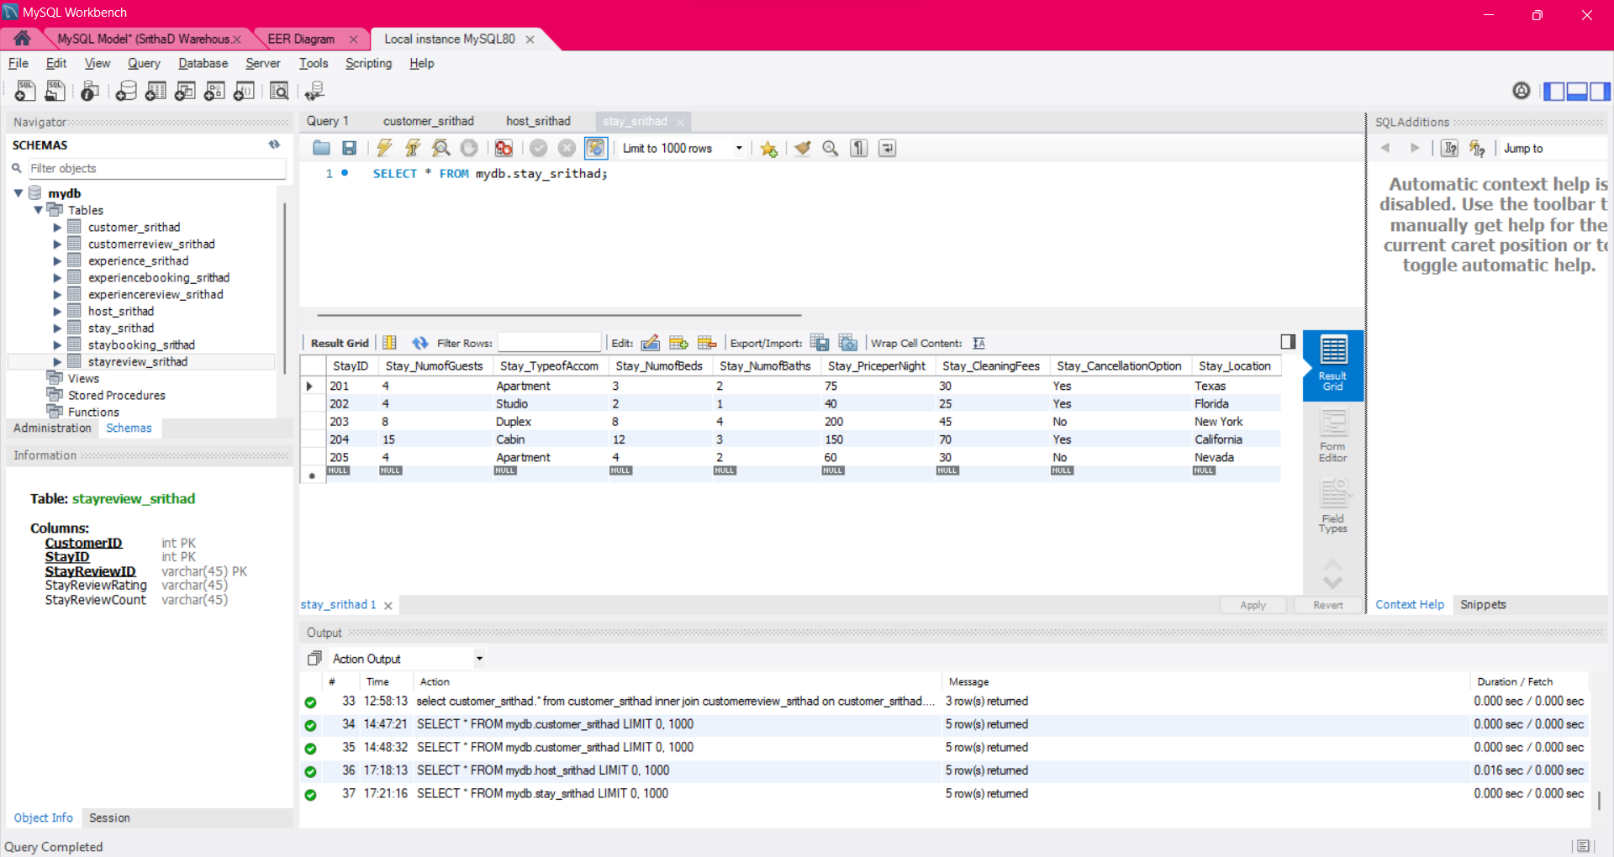

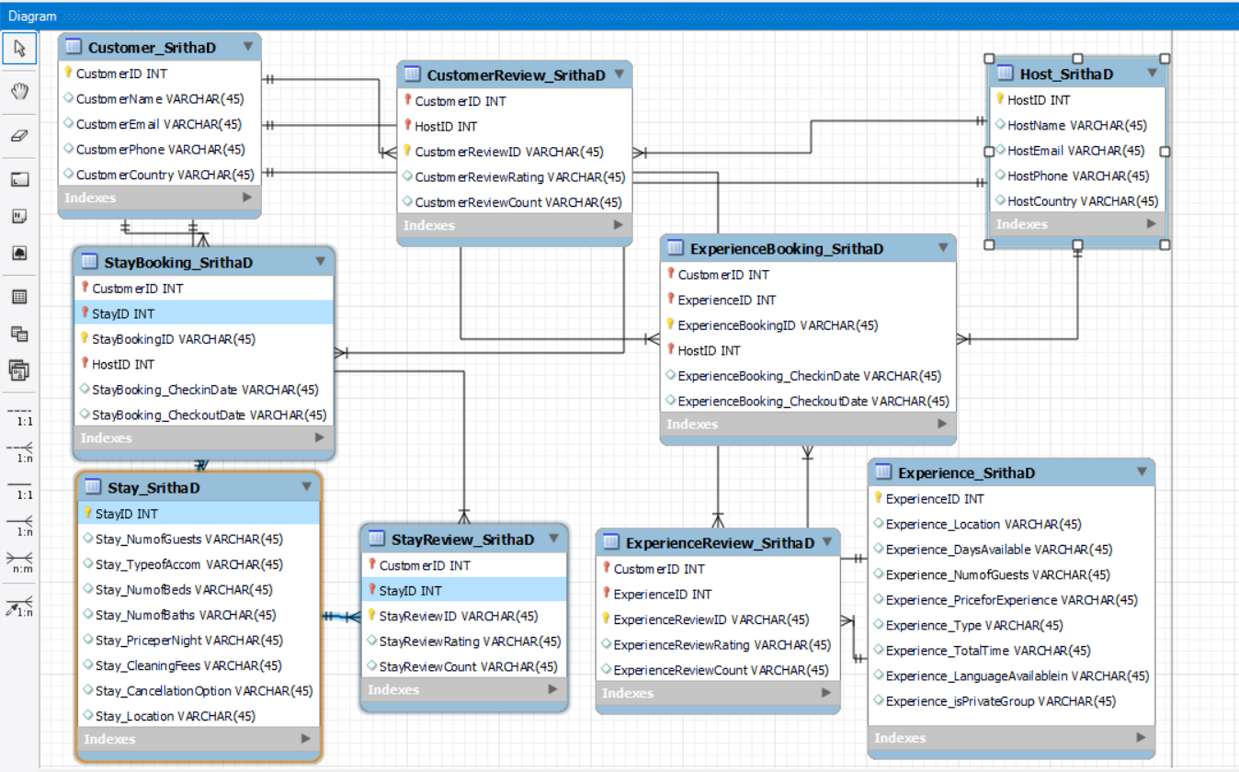

StayID is the Primary Key in this table. There are no Foreign Keys. This table has 9 entities and 5 attributes.

This table has relations with StayBooking_SrithaD and StayReview_SrithaD tables.

**Table 4: Experience_SrithaD**

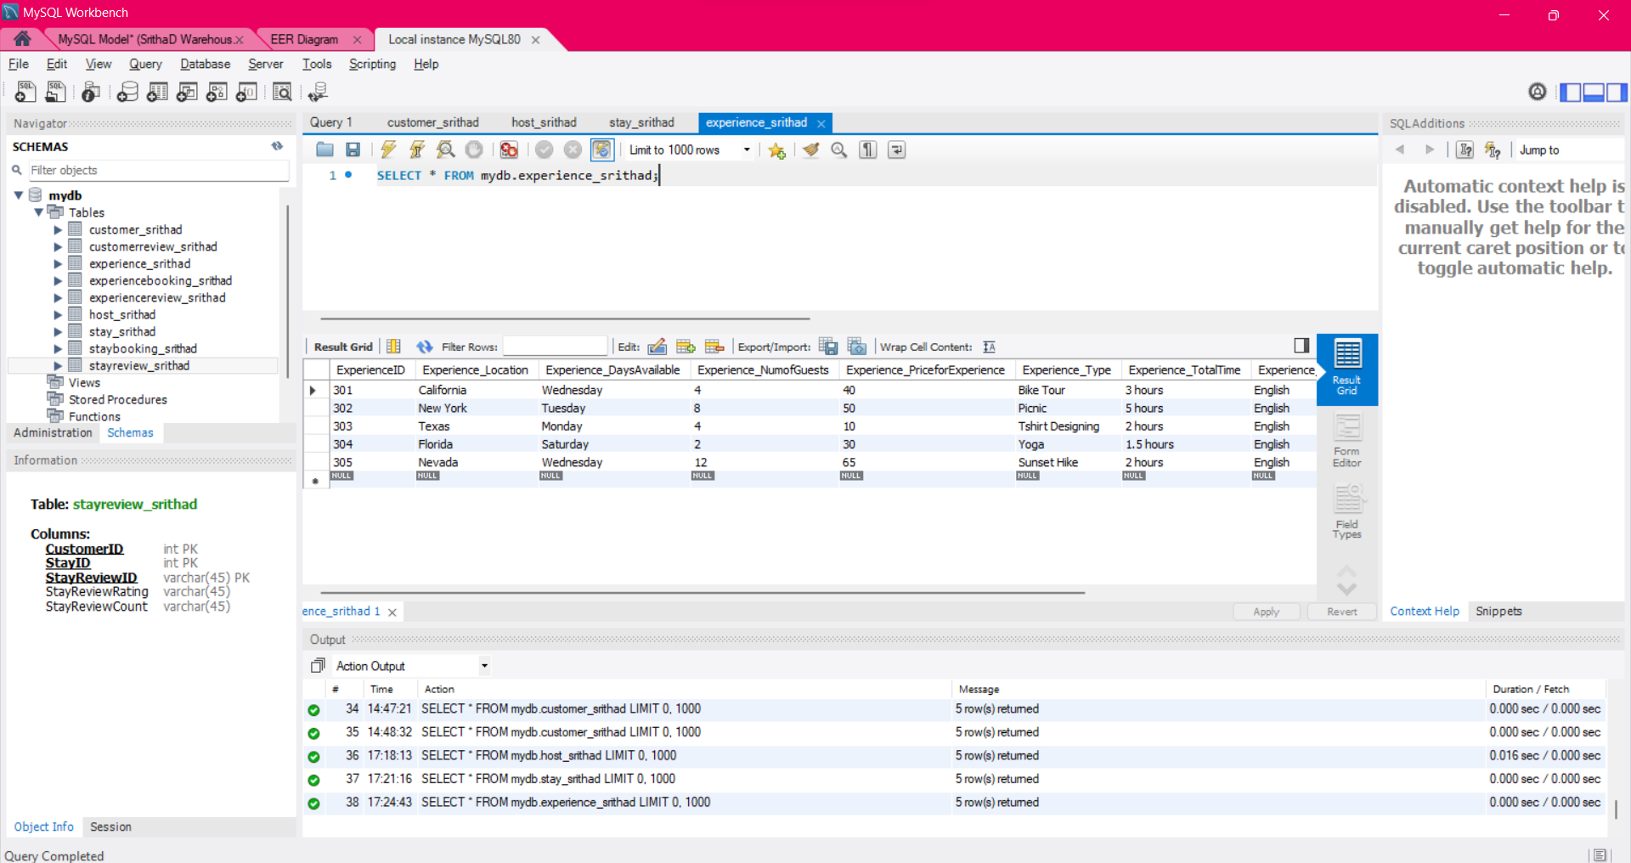

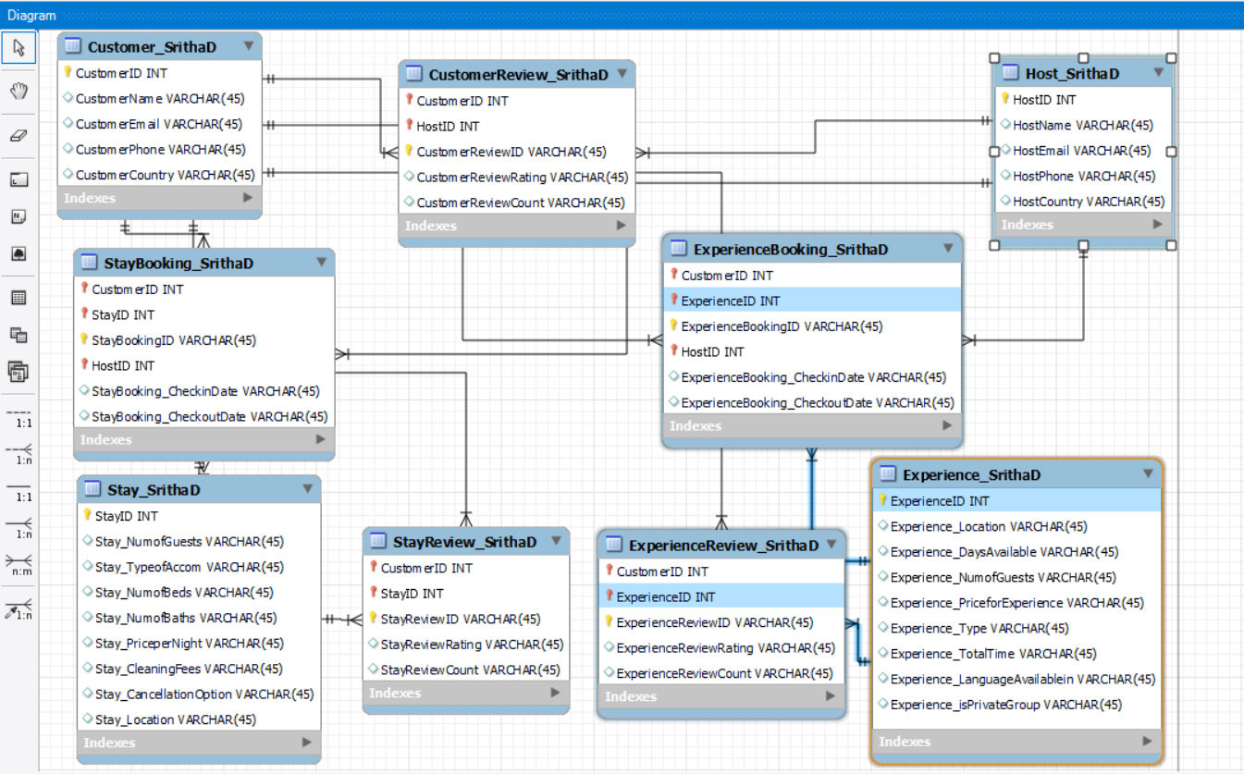

ExperienceID is the Primary Key in this table. There are no Foreign Keys. This table has 9 entities and 5 attributes.

This table has relations with ExperienceBooking_SrithaD and ExperienceReview_SrithaD tables.

**Table 5: StayBooking_SrithaD**

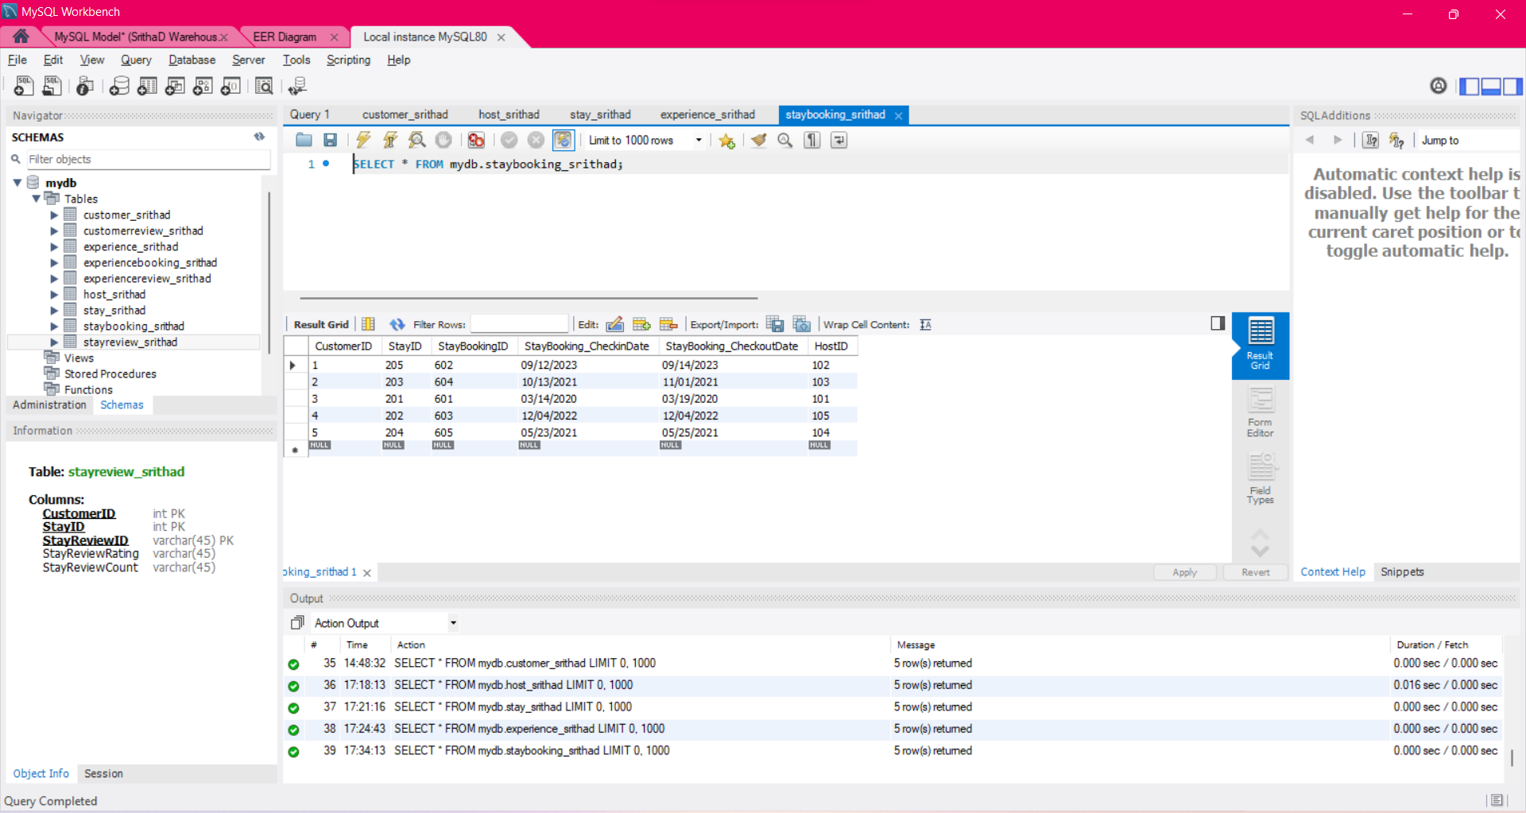

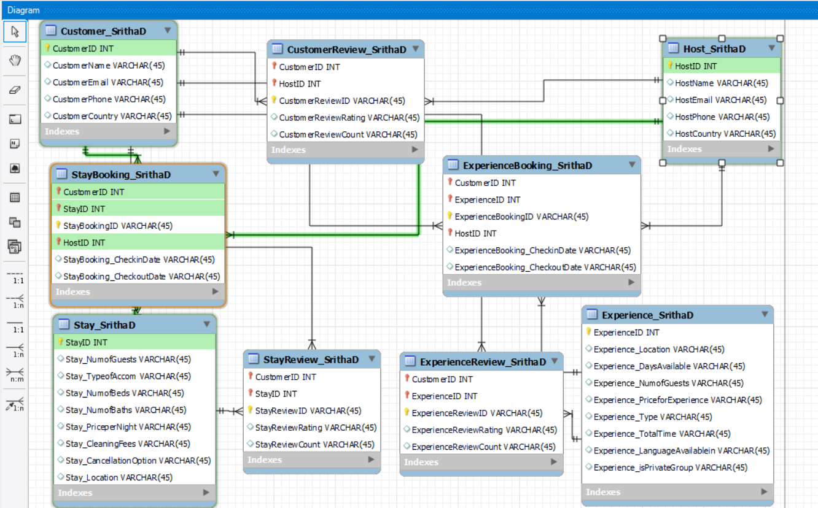

StayBookingID is the Primary Key in this table. CustomerID, StayID and HostID are the Foreign Keys.

This table is an associate table between Customer_SrithaD, Stay_SrithaD and Host_SrithaD. This table has 6 entities and 5 attributes.

**Table 6: ExperienceBooking_SrithaD**

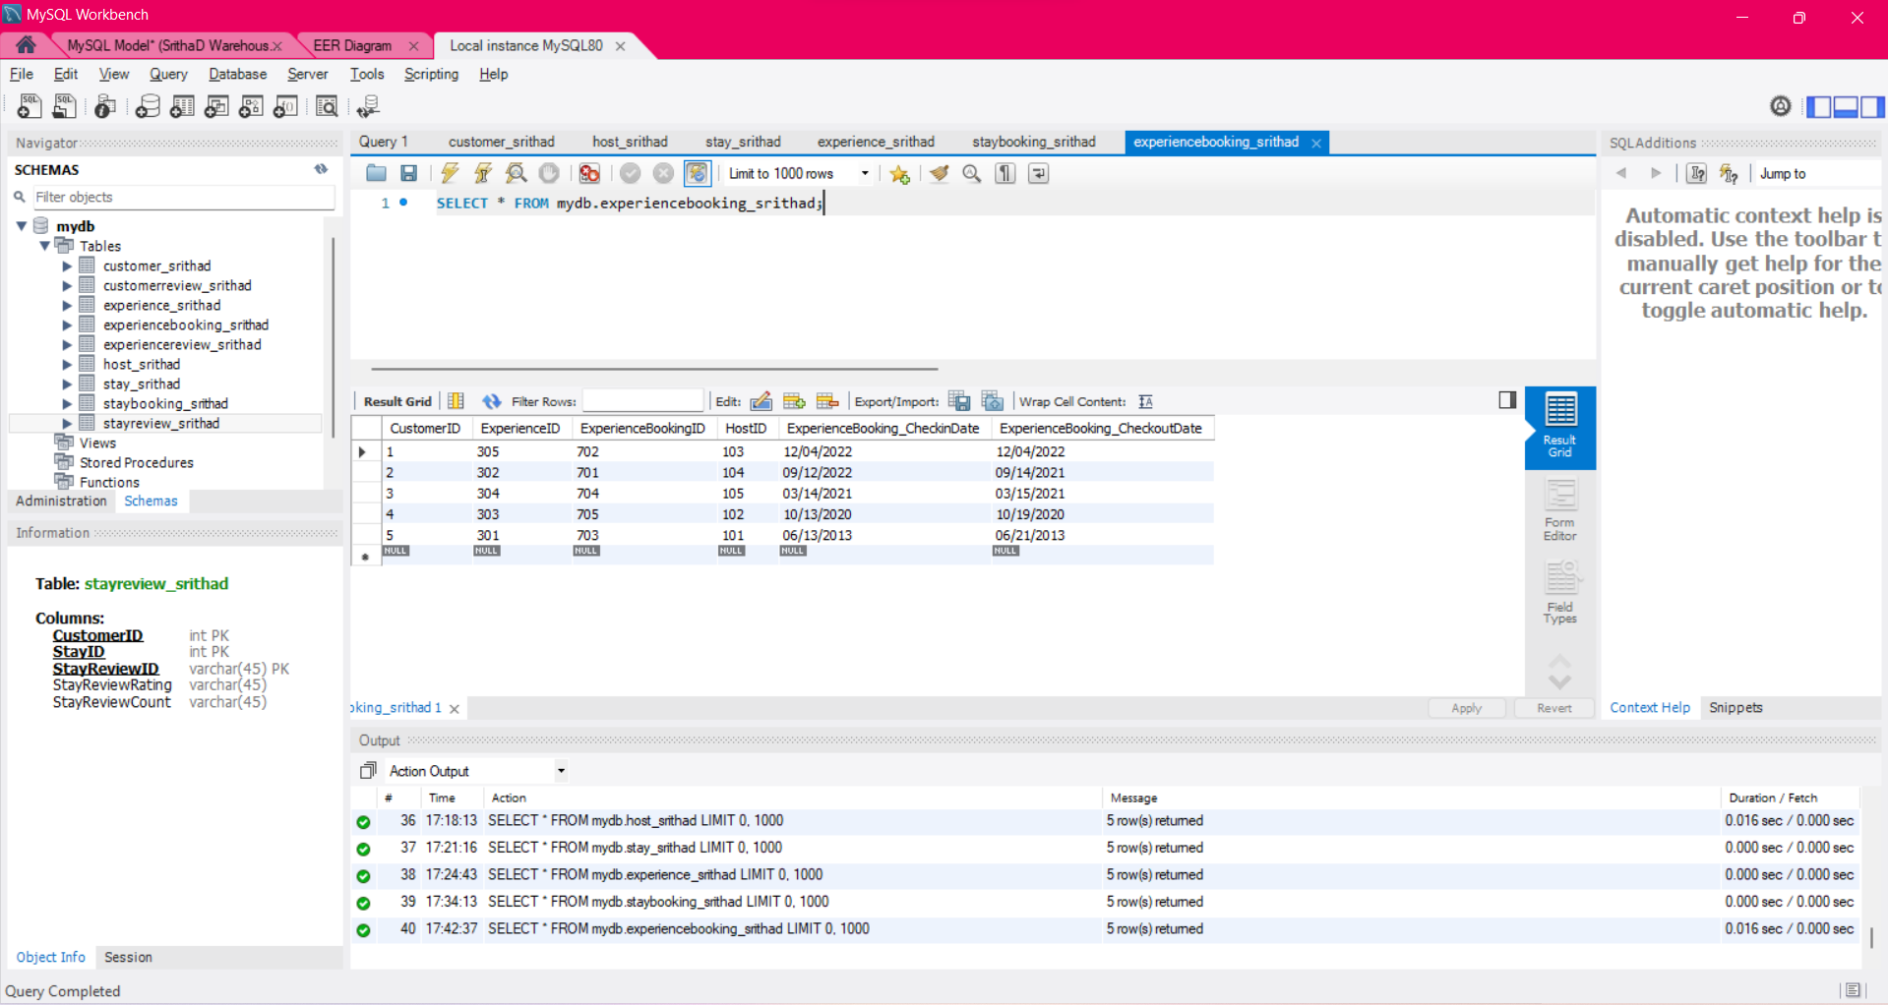

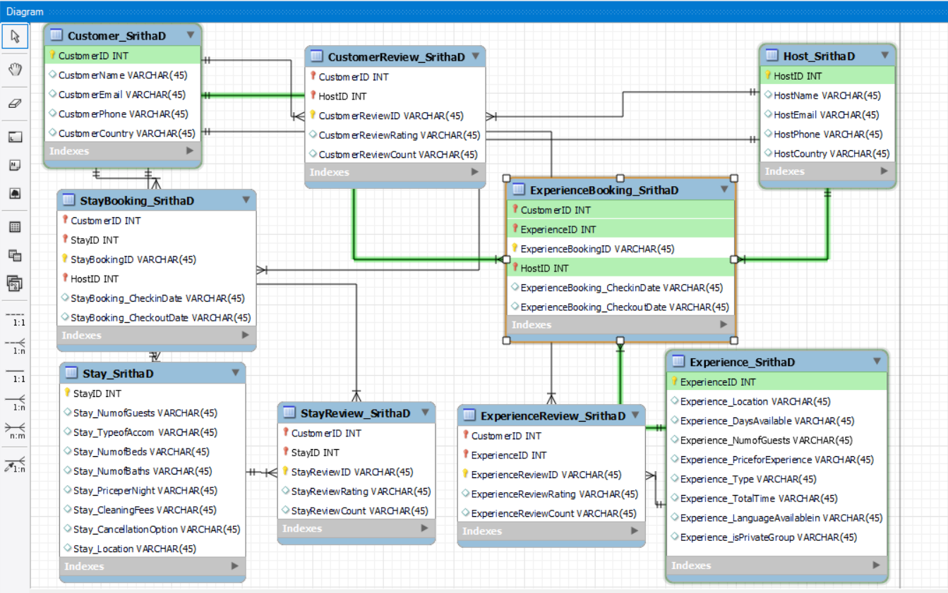

ExperienceBookingID is the Primary Key in this table. CustomerID, ExperienceID and HostID are the Foreign Keys.

This table is an associate table between Customer_SrithaD, Experience_SrithaD and Host_SrithaD. This table has 6 entities and 5 attributes.

**Table 7: CustomerReview_SrithaD**

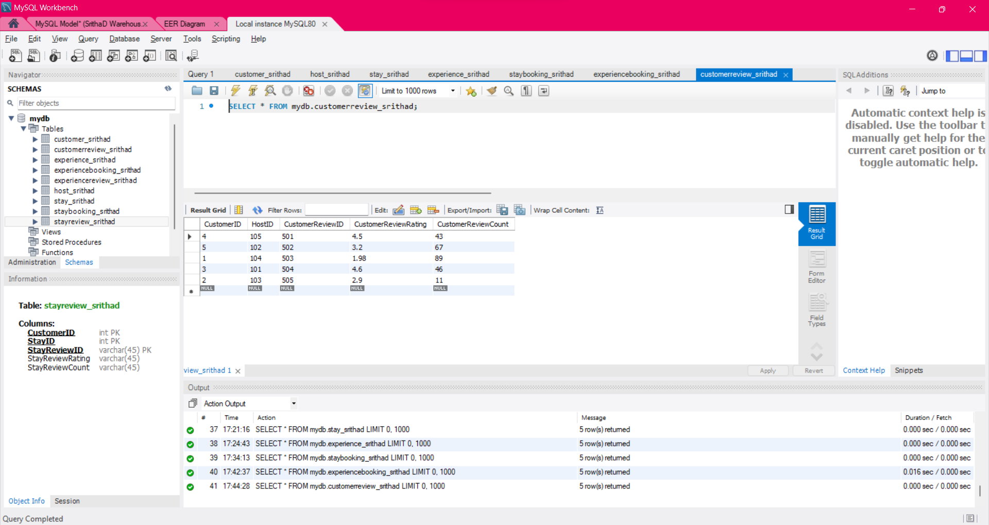

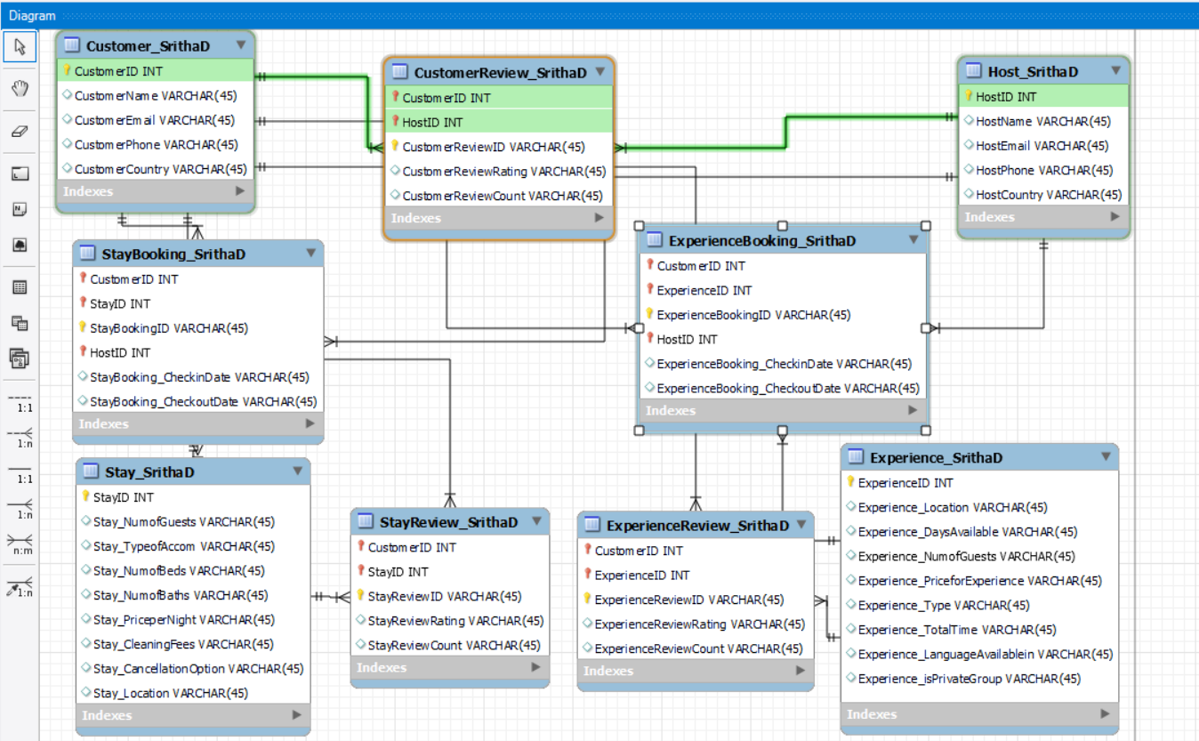

CustomerReviewID is the Primary Key in this table. CustomerID and HostID are the Foreign Keys.

This table is an associate table between Customer_SrithaD and Host_SrithaD. This table has 5 entities and 5 attributes.

**Table 8: StayReview_SrithaD**

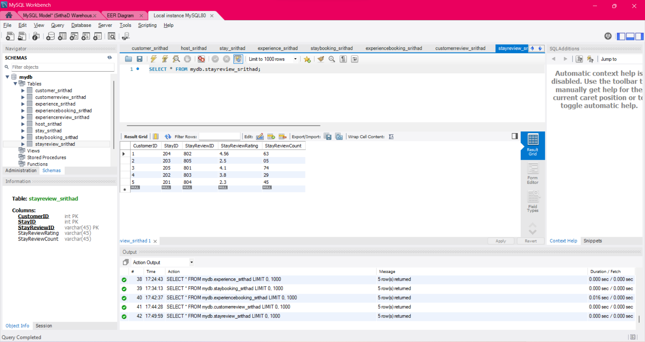

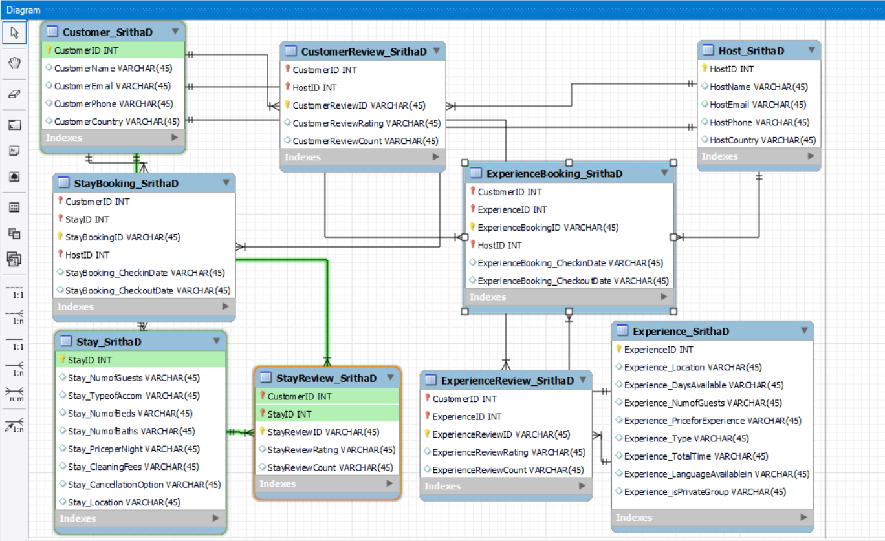

StayReviewID is the Primary Key in this table. CustomerID and StayID are the Foreign Keys.

This table is an associate table between Customer_SrithaD and Stay_SrithaD. This table has 5 entities and 5 attributes.

**Table 9: ExperienceReview_SrithaD**

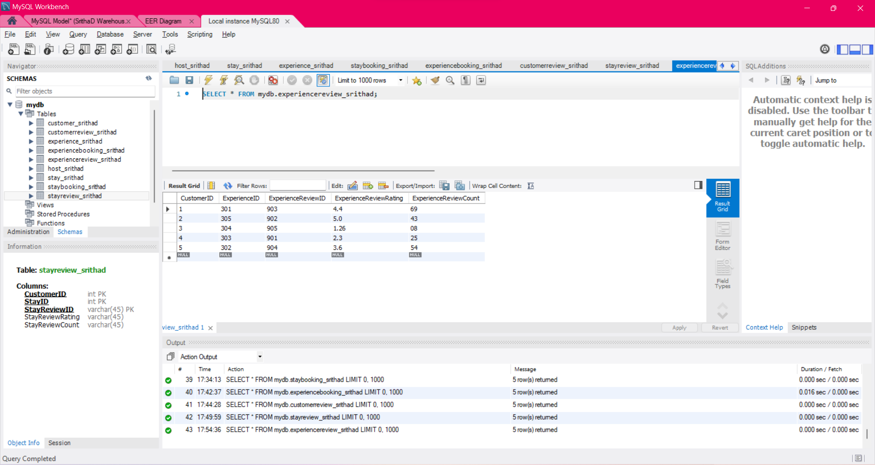

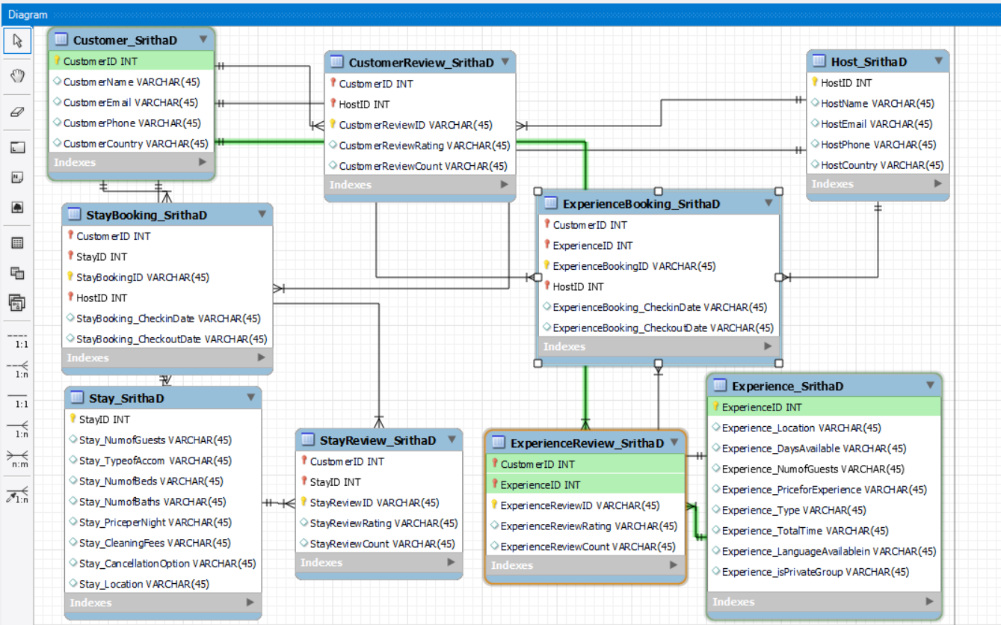

ExperienceReviewID is the Primary Key in this table. CustomerID and ExperienceID are the Foreign Keys.

This table is an associate table between Customer_SrithaD and Experience_SrithaD. This table has 5 entities and 5 attributes.

**Example query run on the database:**

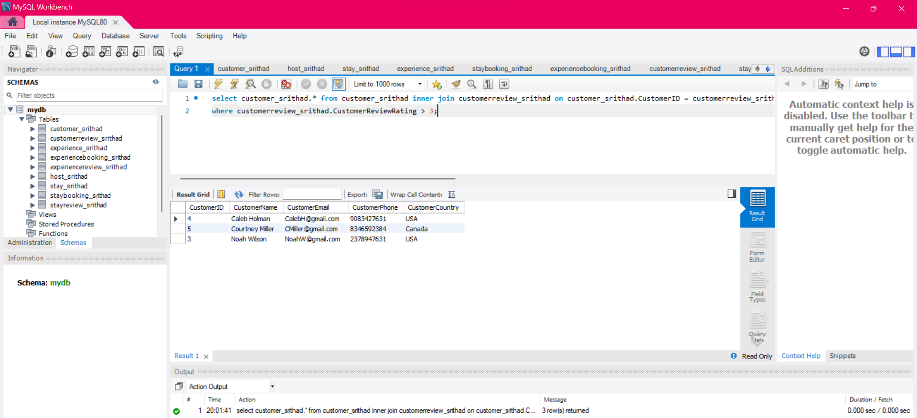

**Dimensional model for Airbnb**

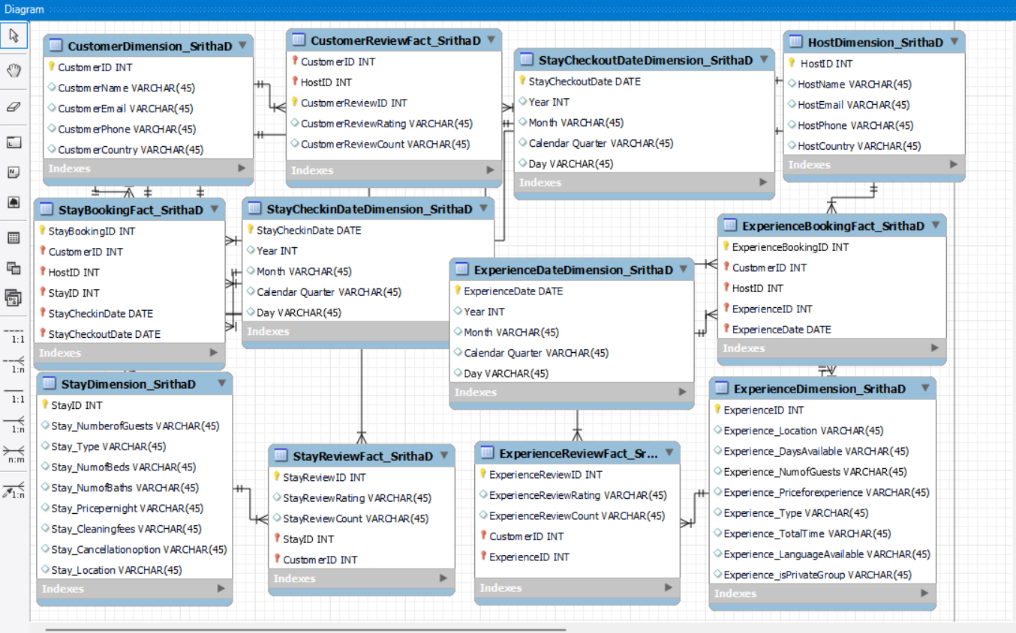

The above Dimension Model Diagram consists of a total of 12 tables with 7 Dimension and 5 Fact Tables.

The following are the Table names:

1.CustomerDimension_SrithaD

2.HostDimension_SrithaD

3.StayDimension_SrithaD

4.ExperienceDimension_SrithaD

5.StayCheckinDateDimension_SrithaD

6.StayCheckoutDateDimension_SrithaD

7.ExperienceDateDimension_SrithaD

8.CustomerReviewFact_SrithaD

9.StayReviewFact_SrithaD

10.ExperienceReviewFact_SrithaD

11.StayBookingFact_SrithaD

12.ExperienceBookingFact_SrithaD

More details about the tables are given below:

|  |
| --- |
| **Table 1: CustomerDimension_SrithaD** This table has CustomerID as the Primary Key. There are no Foreign Keys. There are five columns in this table. |
| **Table 2: HostDimension_SrithaD** This table has HostID as the Primary Key. There are no Foreign Keys. There are five columns in this table. |
| **Table 3: StayDimension_SrithaD**   |
| This table has StayID as the Primary Key. There are no Foreign Keys. There are nine columns in this table. |
| **Table 4: ExperienceDimension_SrithaD** This table has ExperienceID as the Primary Key. There are no Foreign Keys. There are nine columns in this table. |
| **Table 5: StayCheckinDateDimension_SrithaD** This table has StayCheckinDate as the Primary Key. There are no Foreign Keys in this table. There are five columns in this table. |
| **Table 6: StayCheckoutDateDimension_SrithaD**   |
| This table has StayCheckoutDate as the Primary Key. There are no Foreign Keys in this table. There are five columns in this table. |
| **Table 7: ExperienceDateDimension_SrithaD**   |
| This table has ExperienceDate as the Primary Key. There are no Foreign Keys in this table. There are five columns in this table. |
| **Table 8: CustomerReviewFact_SrithaD**     |
| This table has CustomerReviewID as the Primary Key. There are two Foreign Keys in this table. There are five columns in this table. |
| **Table 9: StayReviewFact_SrithaD** This table has StayReviewID as the Primary Key. There are two Foreign Keys in this table. There are five columns in this table. |
| **Table 10: ExperienceReviewFact_SrithaD**   |
|  |
| This table has ExperienceReviewID as the Primary Key. There are two Foreign Keys in this table. There are five columns in this table. |
|  |
| **Table 11: StayBookingFact_SrithaD**     |
| This table has StayBookingID as the Primary Key. There are five Foreign Keys in this table. There are six columns in this table. |
|  |
| **Table 12: ExperienceBookingFact_SrithaD** |

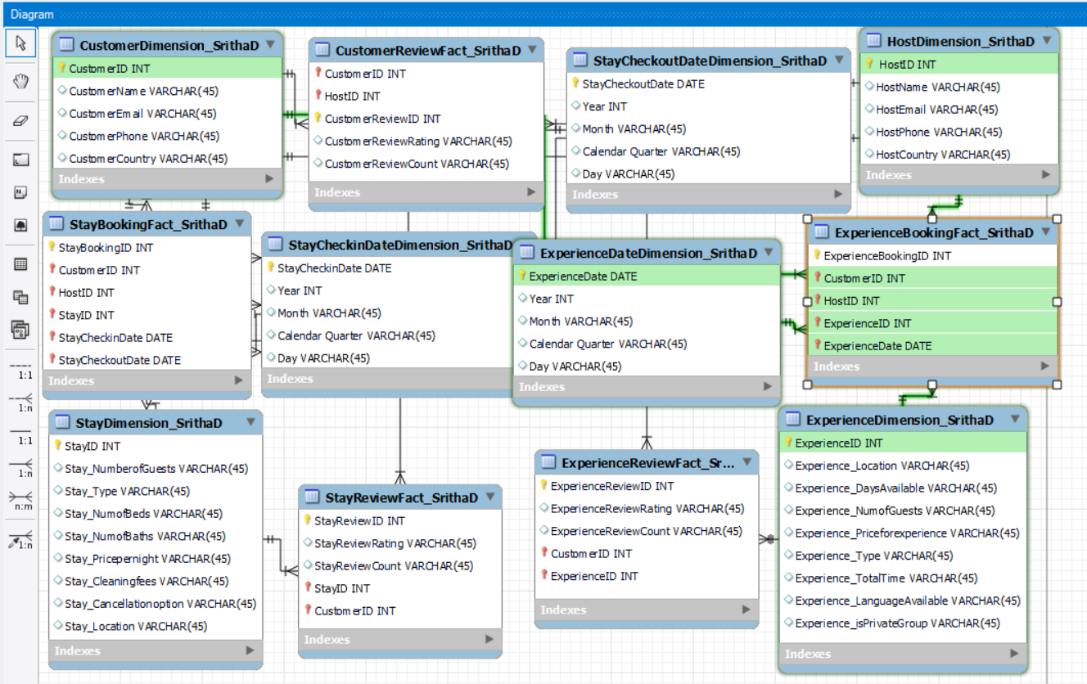

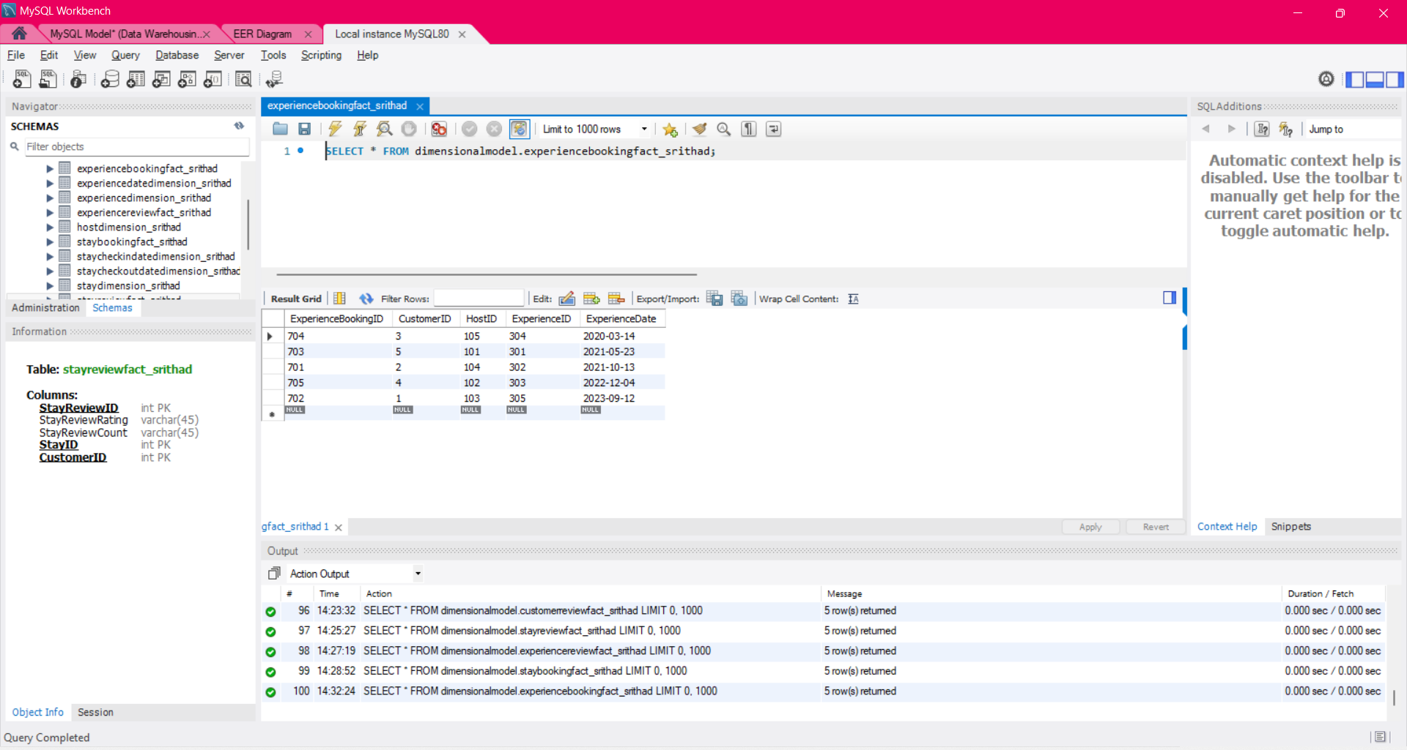

This table has ExperienceBookingID as the Primary Key. There are four Foreign Keys in this table. There are five columns in this table.

I have run the following example query:

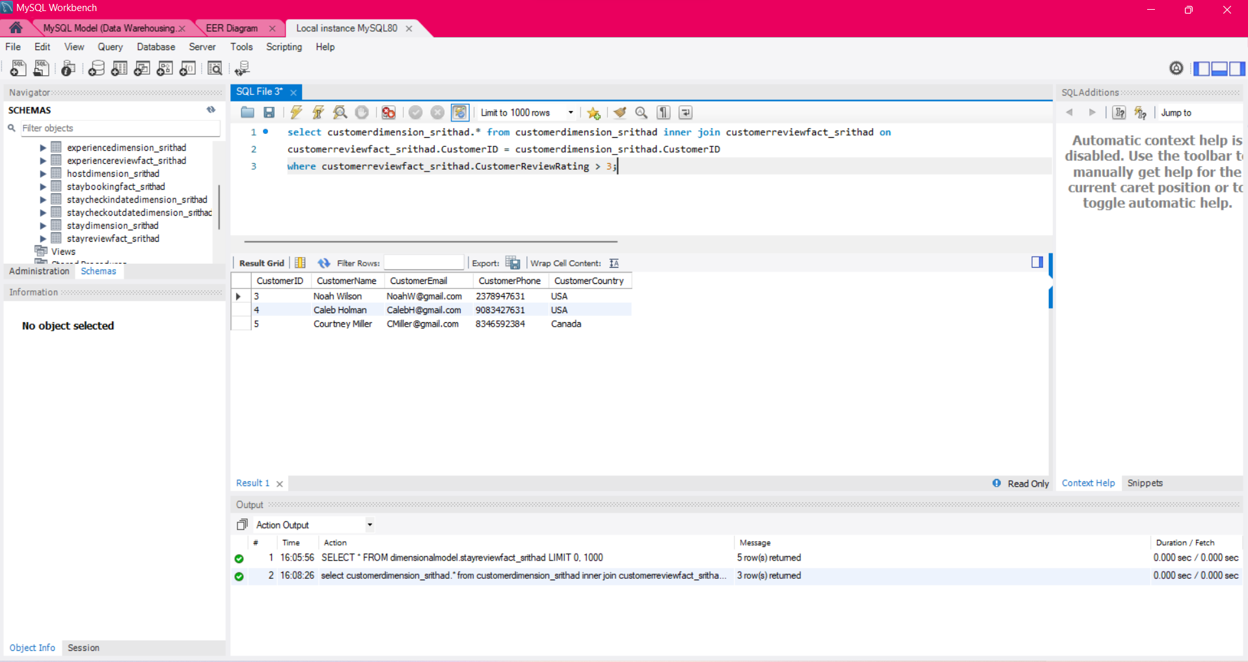

**Design Document for Airbnb Dimensional Model**

Introduction: I have created a Dimension Model Diagram for Airbnb Website basing on the ER Diagram created for Assignment 1 and considering limitations as specified in Assignment 1. My model consists of a total of 12 tables.

General Overview: Dimension Model mainly consists of two types of tables: 1. Dimension Table and 2. Fact Table. Dimension tables primarily consists of textual attributes, whereas Fact tables consists of Measures, Degenerate Dimensions and Foreign Keys from One-many relation of the Dimension tables. For my model, I have created a total of 12 tables, with 7 tables as Dimension tables and 5 tables as Fact tables. I have joined the Dimension tables with the Fact Tables using One-Many Relationship, with Many side on the Fact table. I have designed Dimension tables so as to contain the context of the Fact table attributes. I have populated each table with 5 row entries.

Architecture Design: In this section, I will clearly describe each of my table and its entities.

1. CustomerDimension_SrithaD

This is a Dimension table which contains details about the Customer for Airbnb. I have used five entities for this table: ID, name, email, phone and country. This Dimension table is a Confirmed Dimension with 5 Fact tables.

1. HostDimension_SrithaD

This is a Dimension table which contains details about the Host for Airbnb. I have used five entities for this table: ID, name, email, phone and country. This Dimension table is a Confirmed Dimension with 3 Fact tables.

1. StayDimension_SrithaD

This is a Dimension table which contains details about the Stays registered for Airbnb. I have used nine entities for this table: ID, Number of Guests, Type, Number of Bedrooms, Number of Baths, Price per Night, Cleaning Fees, Cancellation Option, Location. This Dimension table is a Confirmed Dimension with 2 Fact tables.

1. ExperienceDimension_SrithaD

This is a Dimension table which contains details about the Experiences given by hosts for Airbnb. I have used nine entities for this table: ID, Location, Days Available, Number of Guests, Price for Experience, Experience Type, Experience Total Time, Languages Available, if the experience has a Private Group option. This Dimension table is a Confirmed Dimension with 2 Fact tables.

1. StayCheckinDateDimension_SrithaD

This is a Dimension table which contains details about the Checkin Dates for Stay bookings. I have used five entities for this table: Checkin Date, Year, Month, Calendar Quarter, Day. This Dimension table is a Time Dimension. I have created this table so as to know more details like How many customers have checked in inbetween a certain time period, month, etc.,

1. StayCheckoutDateDimension_SrithaD

This is a Dimension table which contains details about the Checkout Dates for Stay bookings. I have used five entities for this table: Checkout Date, Year, Month, Calendar Quarter, Day. This Dimension table is a Time Dimension. I have created this table so as to know more details like How many customers have checked out inbetween a certain time period, month, years, etc.,

1. ExperienceDateDimension_SrithaD

This is a Dimension table which contains details about the Experience Date for Experience bookings. I have used five entities for this table: Experience Date, Year, Month, Calendar Quarter, Day. This Dimension table is a Time Dimension. I have created this table so as to know more details like How many customers have had a particular experience inbetween a certain time period, month, years, etc.,

1. CustomerReviewFact_SrithaD

This is a Fact table which contains details about the Customer Reviews left by hosts to the customers. It has two foreign keys from the dimension tables, a surrogate key CustomerReviewID as the primary key and two degenerate dimensions.

1. StayReviewFact_SrithaD

This is a Fact table which contains details about the Stay Reviews left by Customers to the stays. It has two foreign keys from the dimension tables, a surrogate key StayReviewID as the primary key and two degenerate dimensions.

1. ExperienceReviewFact_SrithaD

This is a Fact table which contains details about the Experience Reviews left by Customers to the Experience. It has two foreign keys from the dimension tables, a surrogate key ExperienceReviewID as the primary key and two degenerate dimensions.

1. StayBookingFact_SrithaD

This is a Fact table which contains details about the Stay Bookings done by Customers. It has five foreign keys from the dimension tables and a surrogate key StayBookingID as the primary key.

1. ExperienceBookingFact_SrithaD

This is a Fact table which contains details about the Experience Bookings done by Customers. It has four foreign keys from the dimension tables and a surrogate key ExperienceBookingID as the primary key.

**Data Visualization using QlikView for Dimensional Model**

I have chosen to connect Qlikview over my Dimensional Model Database.

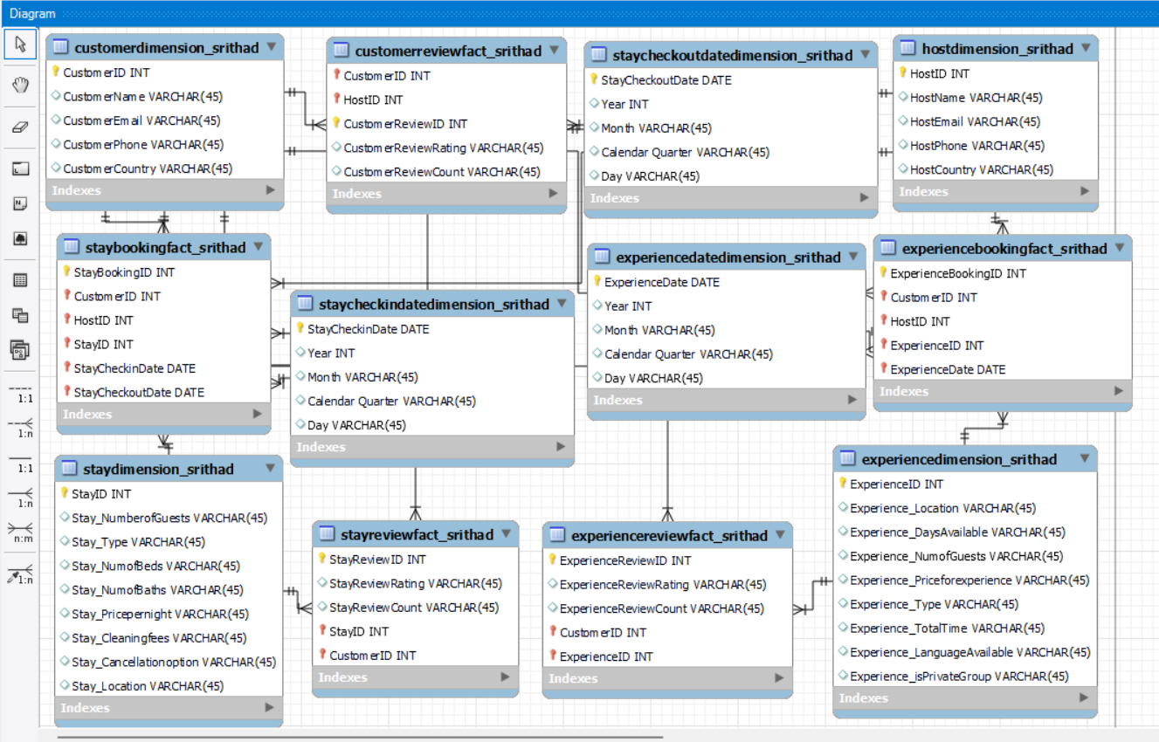

BackEnd of the datamodel:

I have created three tabs for the backend of the database.

1. Main Tab

2. Loading Tables Tab

3. Information Tab

* The Main tab contains the default set values and the connection to the database.

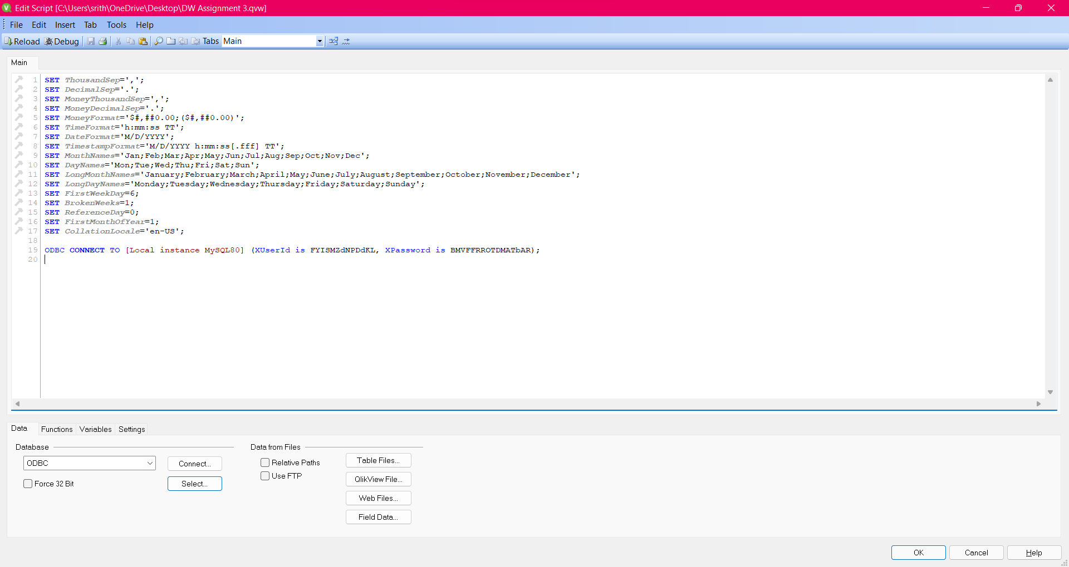

* The Loading tables tab contains scripts for loading tables into the qlikview

/**************************************************************************************CUSTOMER TABLE*************************************************************************************************/  
'Customers':  
**LOAD** CustomerID AS CustomerID,  
 CustomerName,  
 CustomerEmail,  
 CustomerPhone,  
 CustomerCountry;  
**SQL** SELECT *  
FROM dimensionalmodel.`customerdimension_srithad`;  
  
/****************************************************************************************HOST TABLE***************************************************************************************************/  
'Hosts':  
**LOAD** ` HostID` as HostID,  
 HostName,  
 HostEmail,  
 HostPhone,  
 HostCountry;  
**SQL** SELECT *  
FROM dimensionalmodel.`hostdimension_srithad`;  
  
/****************************************************************************************STAY TABLE***************************************************************************************************/  
'Stays':  
**LOAD** StayID,  
 `Stay_NumberofGuests`,  
 `Stay_Type`,  
 `Stay_NumofBeds`,  
 `Stay_NumofBaths`,  
 `Stay_Pricepernight`,  
 `Stay_Cleaningfees`,  
 `Stay_Cancellationoption`,  
 `Stay_Location`;  
**SQL** SELECT *  
FROM dimensionalmodel.`staydimension_srithad`;  
  
/****************************************************************************************EXPERIENCE TABLE*********************************************************************************************/  
'Experiences':  
**LOAD** ExperienceID,  
 `Experience_Location`,  
 `Experience_DaysAvailable`,  
 `Experience_NumofGuests`,  
 `Experience_Priceforexperience`,  
 `Experience_Type`,  
 `Experience_TotalTime`,  
 `Experience_LanguageAvailable`,  
 `Experience_isPrivateGroup`;  
**SQL** SELECT *  
FROM dimensionalmodel.`experiencedimension_srithad`;  
  
/*************************************************************************************STAY CHECKIN DATE TABLE*****************************************************************************************/  
'Check-In Date - Stays':  
**LOAD** StayCheckinDate,  
 Year AS CINYear,  
 Month AS CINMonth,  
 `Calendar Quarter` AS CINQuarter,  
 Day AS CINDay;  
**SQL** SELECT *  
FROM dimensionalmodel.`staycheckindatedimension_srithad`;  
  
/**************************************************************************************STAY CHECKOUT DATE TABLE***************************************************************************************/  
'Check-Out Date - Stays':  
**LOAD** StayCheckoutDate,  
 Year AS COUTYear,  
 Month AS COUTMonth,  
 `Calendar Quarter` AS COUTQuarter,  
 Day AS COUTDay;  
**SQL** SELECT *  
FROM dimensionalmodel.`staycheckoutdatedimension_srithad`;  
  
/**************************************************************************************EXPERIENCE DATE TABLE******************************************************************************************/  
'Date - Experiences':  
**LOAD** ExperienceDate,  
 Year AS ExpYear,  
 Month AS ExpMonth,  
 `Calendar Quarter` AS ExpQuarter,  
 Day AS ExpDay;  
**SQL** SELECT *  
FROM dimensionalmodel.`experiencedatedimension_srithad`;  
  
Inner Keep (Customers)  
Inner keep (Hosts)  
  
/***********************************************************************************CUSTOMER REVIEW TABLE*********************************************************************************************/  
'Customer Reviews':  
**LOAD** CustomerID,  
 HostID,  
 CustomerReviewID,  
 CustomerReviewRating,  
 CustomerReviewCount;  
**SQL** SELECT *  
FROM dimensionalmodel.`customerreviewfact_srithad`;  
  
Inner Keep (Customers)  
Inner keep (Stays)  
  
/***************************************************************************************STAY REVIEW TABLE*********************************************************************************************/  
'Stays Reviews':  
**LOAD** StayReviewID,  
 StayReviewRating,  
 StayReviewCount,  
 StayID,  
 CustomerID;  
**SQL** SELECT *  
FROM dimensionalmodel.`stayreviewfact_srithad`;  
  
Inner Keep (Customers)  
Inner keep (Experiences)  
  
/*********************************************************************************EXPERIENCE REVIEW TABLE*********************************************************************************************/  
'Experience Reviews':  
**LOAD** ExperienceReviewID,  
 ExperienceReviewRating,  
 ExperienceReviewCount,  
 CustomerID,  
 ExperienceID;  
**SQL** SELECT *  
FROM dimensionalmodel.`experiencereviewfact_srithad`;  
  
/**************************************************************************************STAY BOOKING TABLE*********************************************************************************************/  
'Confirmed Bookings - Stays':  
**LOAD** StayBookingID,  
 CustomerID,  
 HostID,  
 StayID,  
 StayCheckinDate,  
 StayCheckoutDate;  
**SQL** SELECT *  
FROM dimensionalmodel.`staybookingfact_srithad`;  
  
/********************************************************************************EXPERIENCE BOOKING TABLE*********************************************************************************************/  
'Confirmed Bookings - Experiences':  
**LOAD** ExperienceBookingID,  
 CustomerID,  
 HostID,  
 ExperienceID,  
 ExperienceDate;  
**SQL** SELECT *  
FROM dimensionalmodel.`experiencebookingfact_srithad`;

For joining some tables, I have used Implicit join and not specified anything else (default full outer join) and for some, I have used Keep for joining the tables and keeping both the tables. There are no loops or circular references in the table structure.

* Table Structure in QlikView

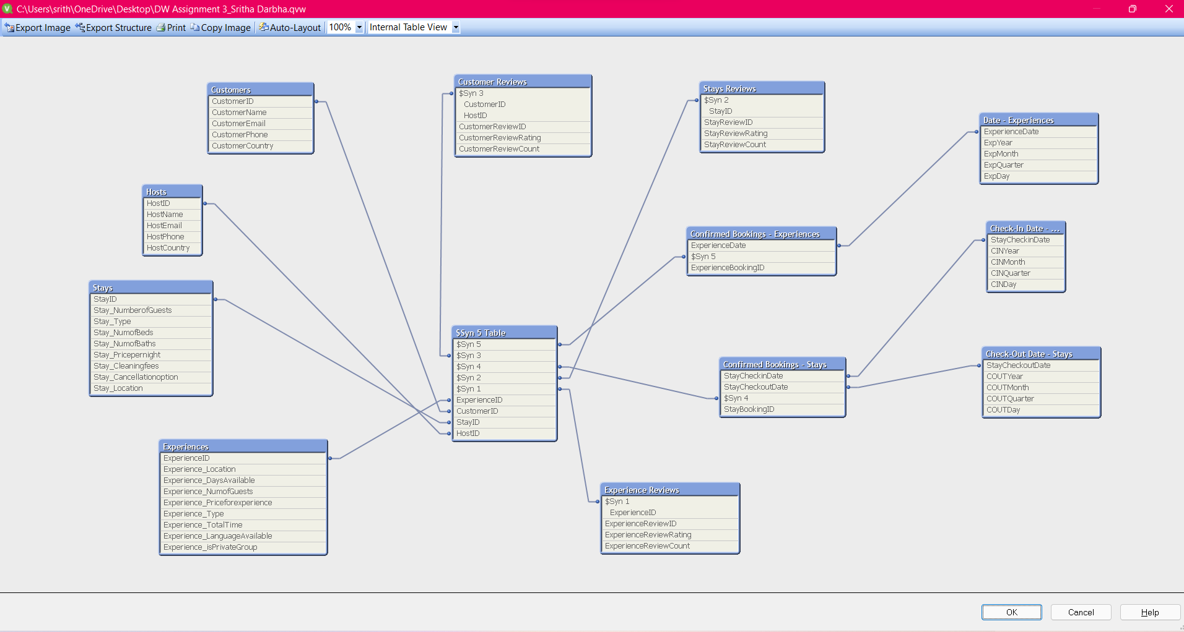

I have already populated the database with 5 records as a part of the previous assignment.

* The Information tab contains information about the creation/updation of the scripts in Qlikview.

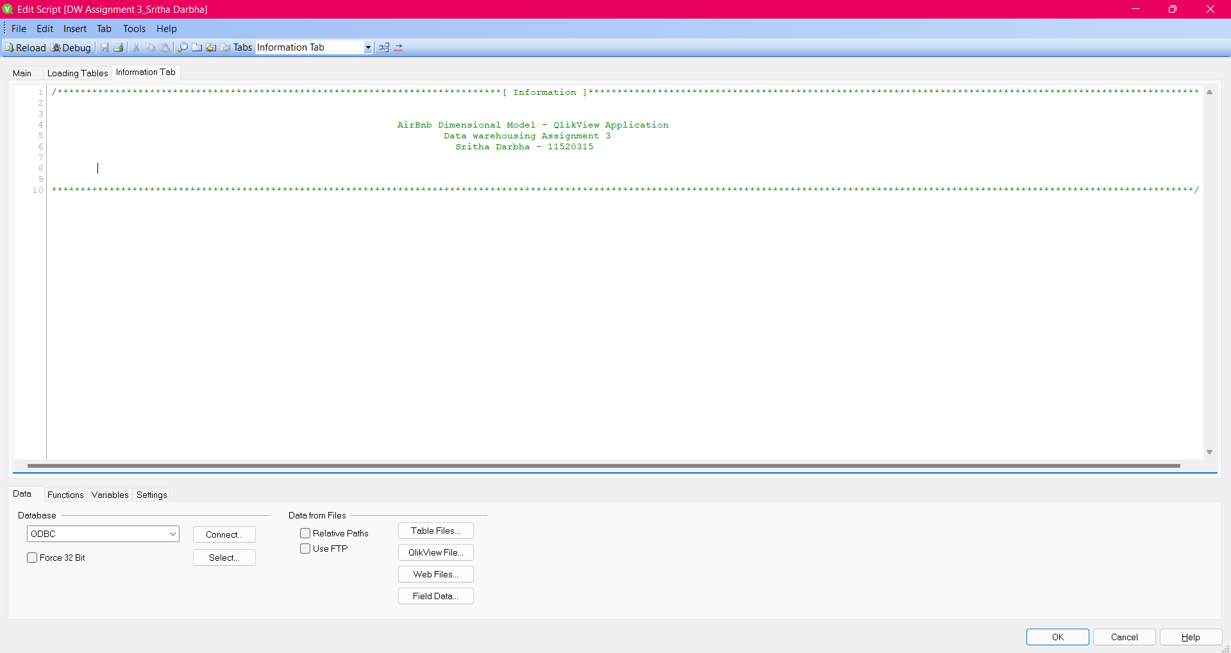

FrontEnd of the datamodel:

For the Front End, I have created 6 tabs:

1. Search – Selections
2. Booking by Month – Charts
3. Bookings by Month – Data
4. Locations
5. Dimension Properties
6. Rating – Reviews

* Search – Selections:

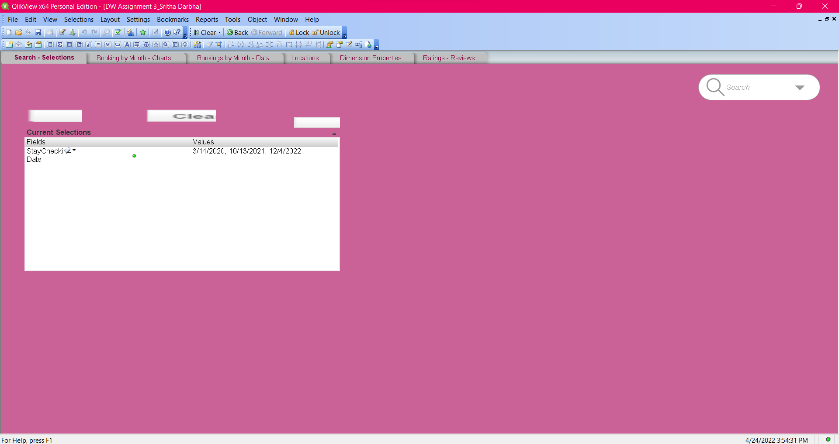

I have used this tab to show Current Selections across all the tabs and for the filter search bar. I have also added forward, backward and clear selection buttons for the Current Selections.

* Booking by Month – Charts

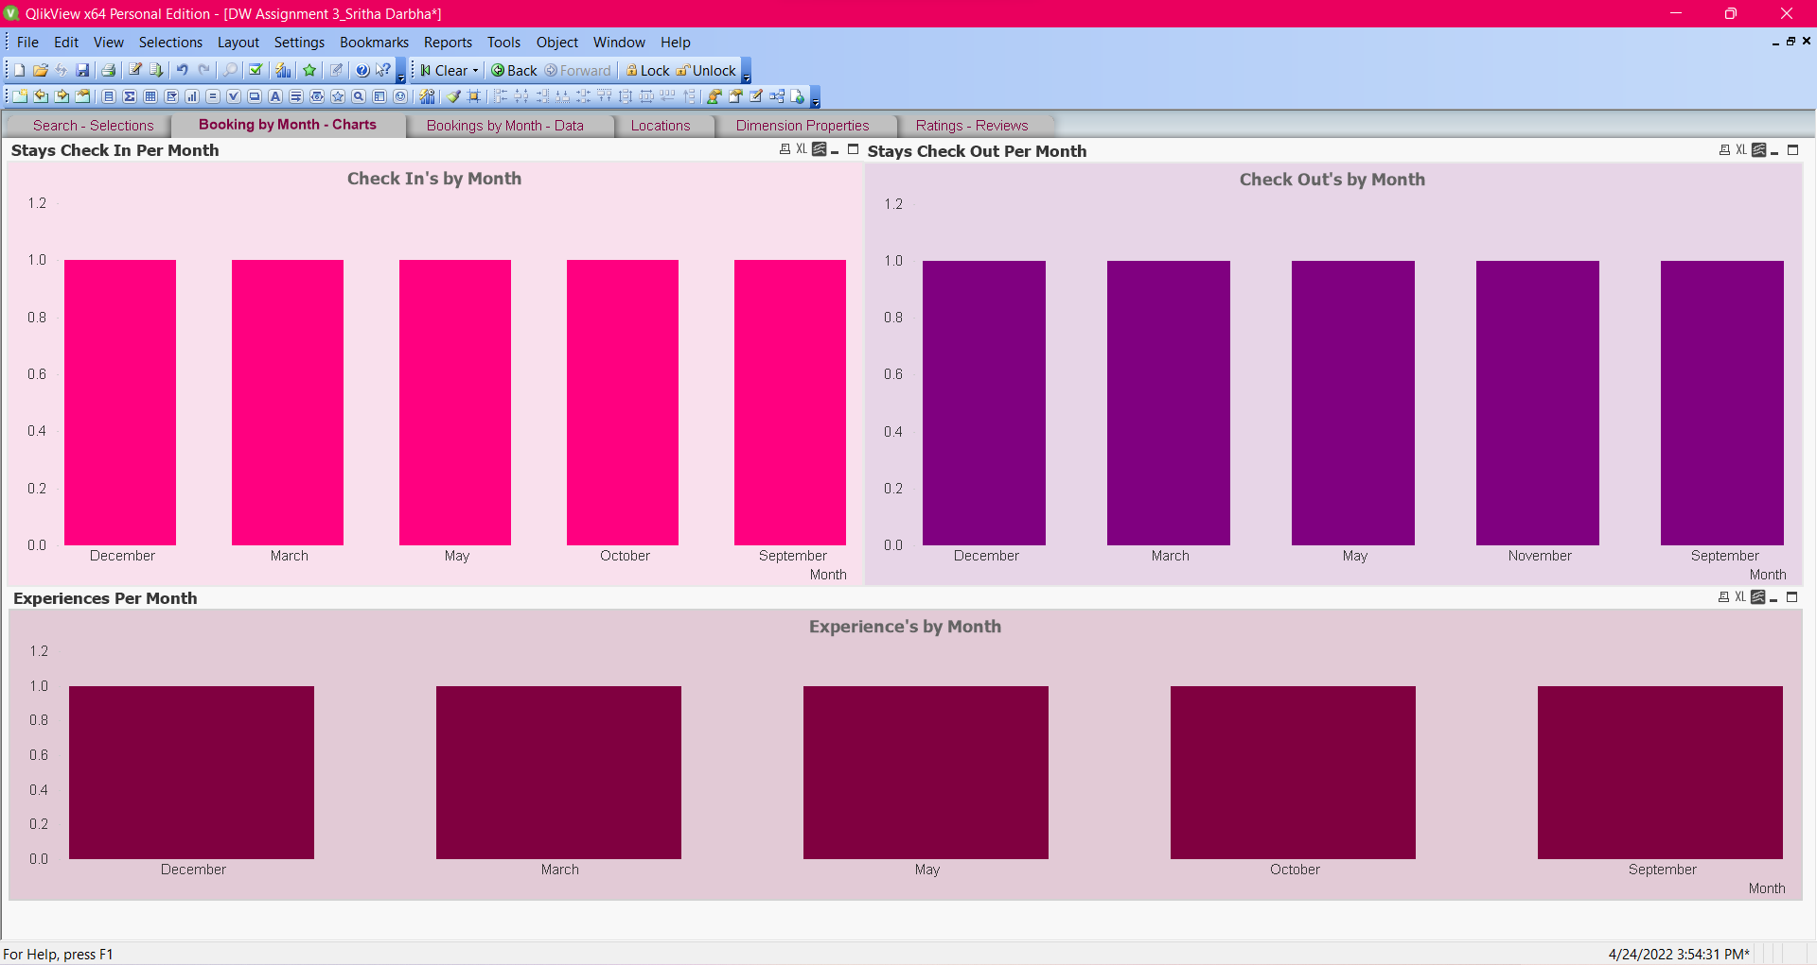

I have used Charts to show the number of Stay Check -In’s , Check -out’s and Experiences by Month.

I have also used Fast-Changing Attribute to show different models of the data.

* Bookings by Month – Data

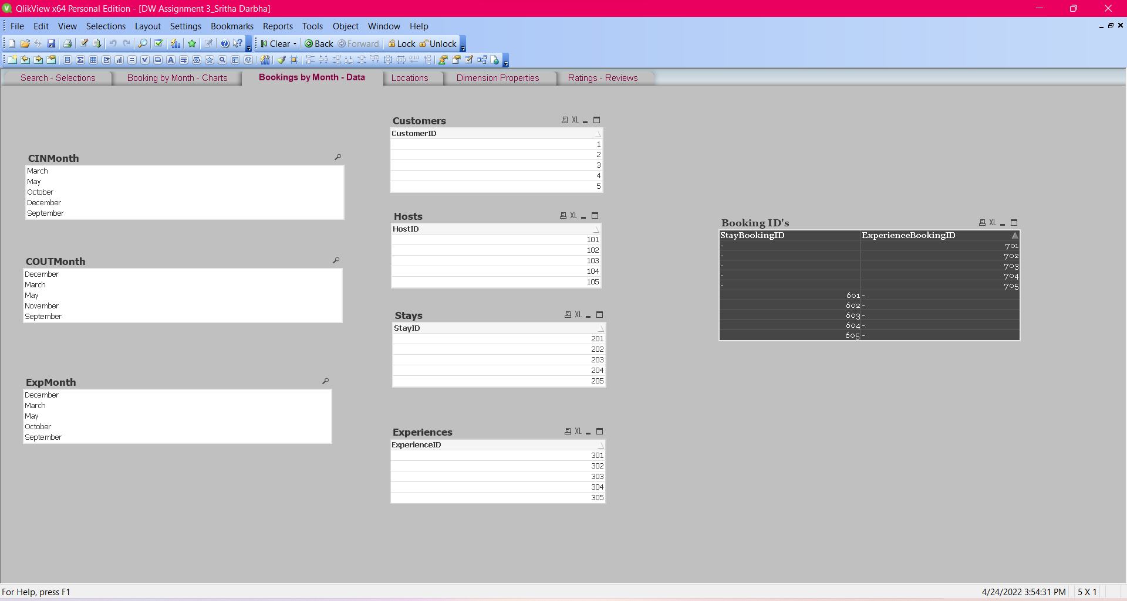

I have used this tab to show data for Customers, Hosts, Stays and Experiences across the different Months and different Bookings.

* Locations

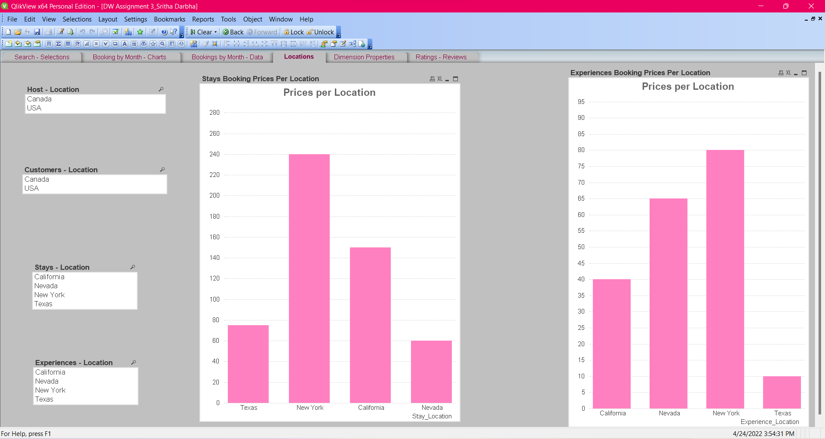

I have used this tab to show Prices for Stays and Experiences across different Locations.

* Dimension Properties

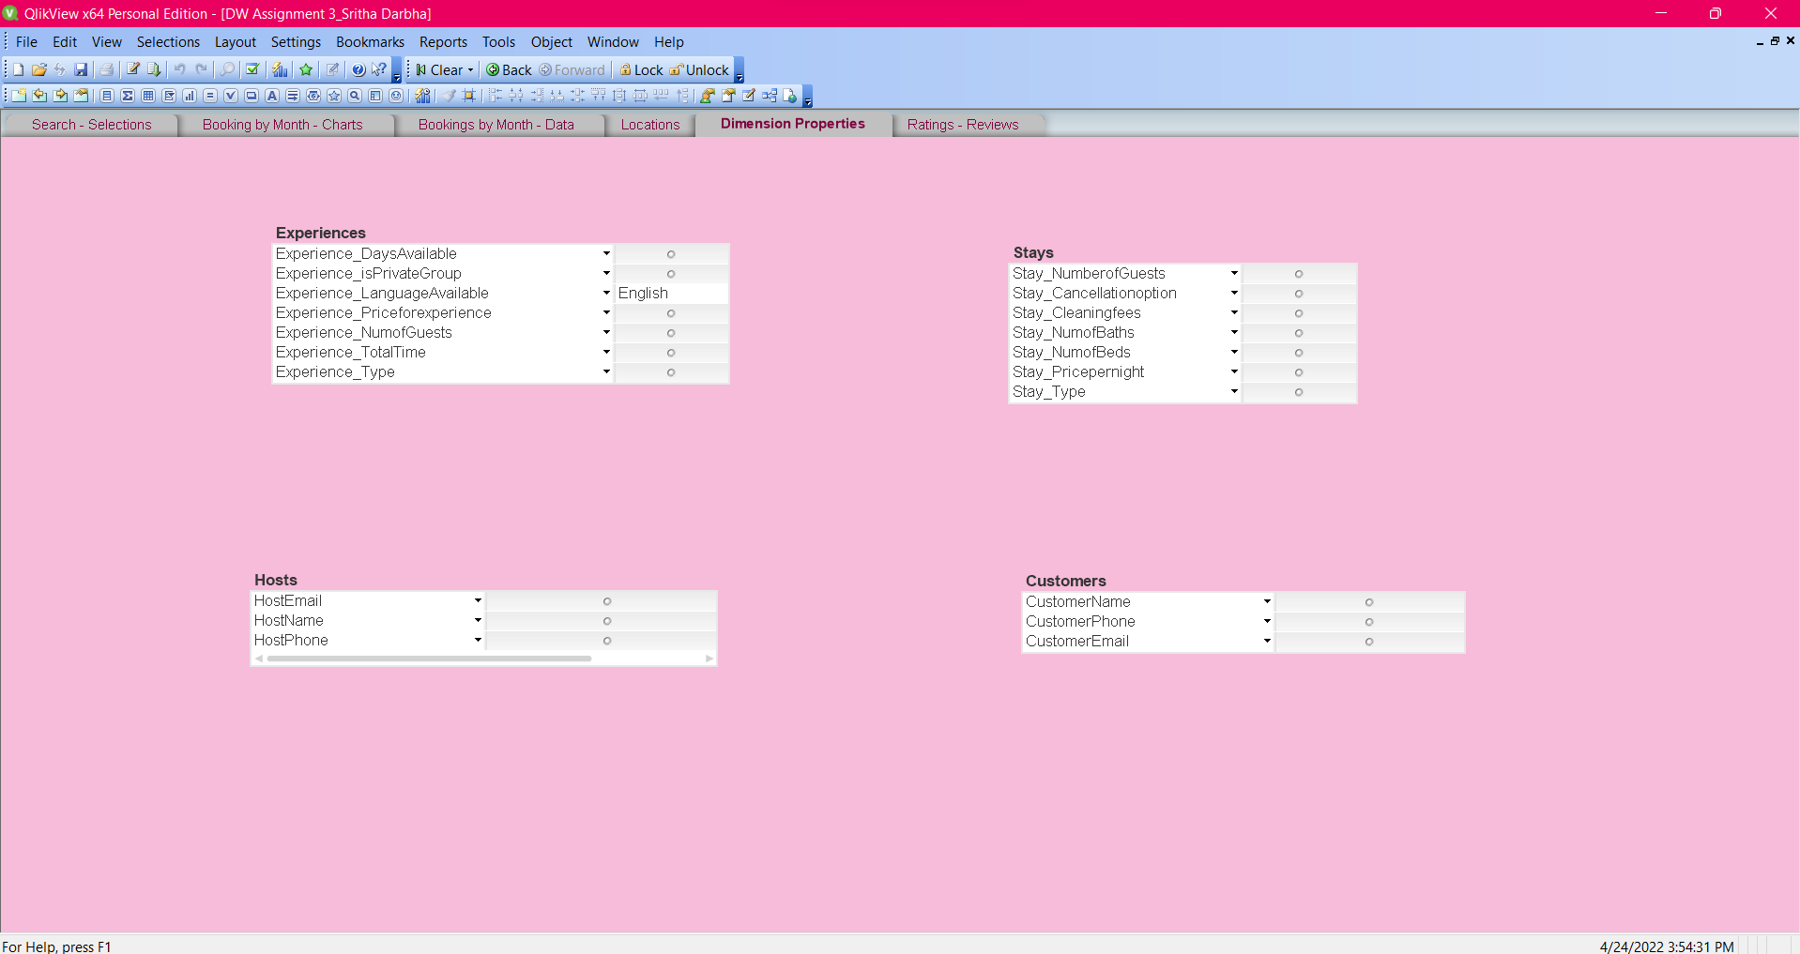

This tab is used to show more details about Experiences, Stays, Hosts and Customers.

* Ratings – Reviews

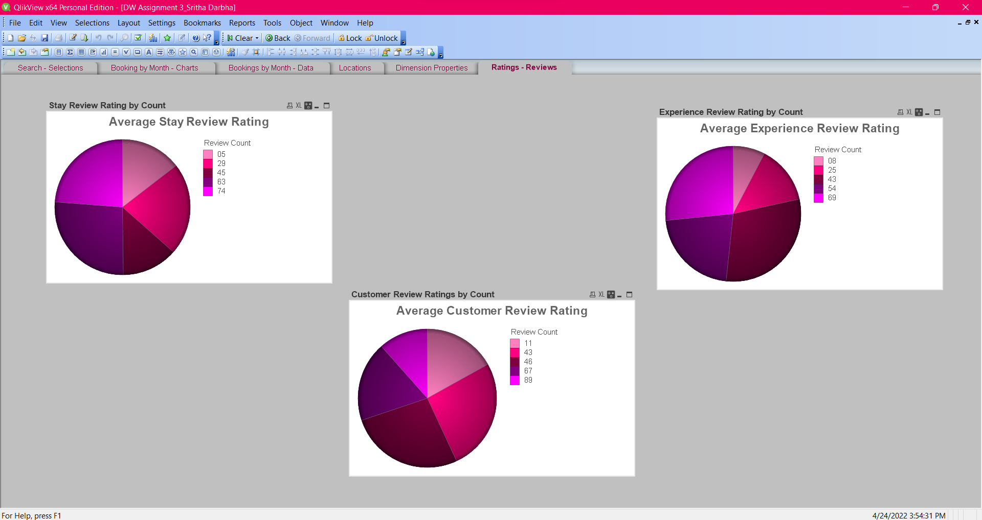

This tab is to show the average ratings by review counts for Customer, Experience and Stay Reviews.

**Data Visualization using Tableau for Dimensional Model**

I’m using the Dimensional Model to visualize data on Tableau

I have created 3 Views from the Database as there are loops and joins and connected and imported those views to Tableau.

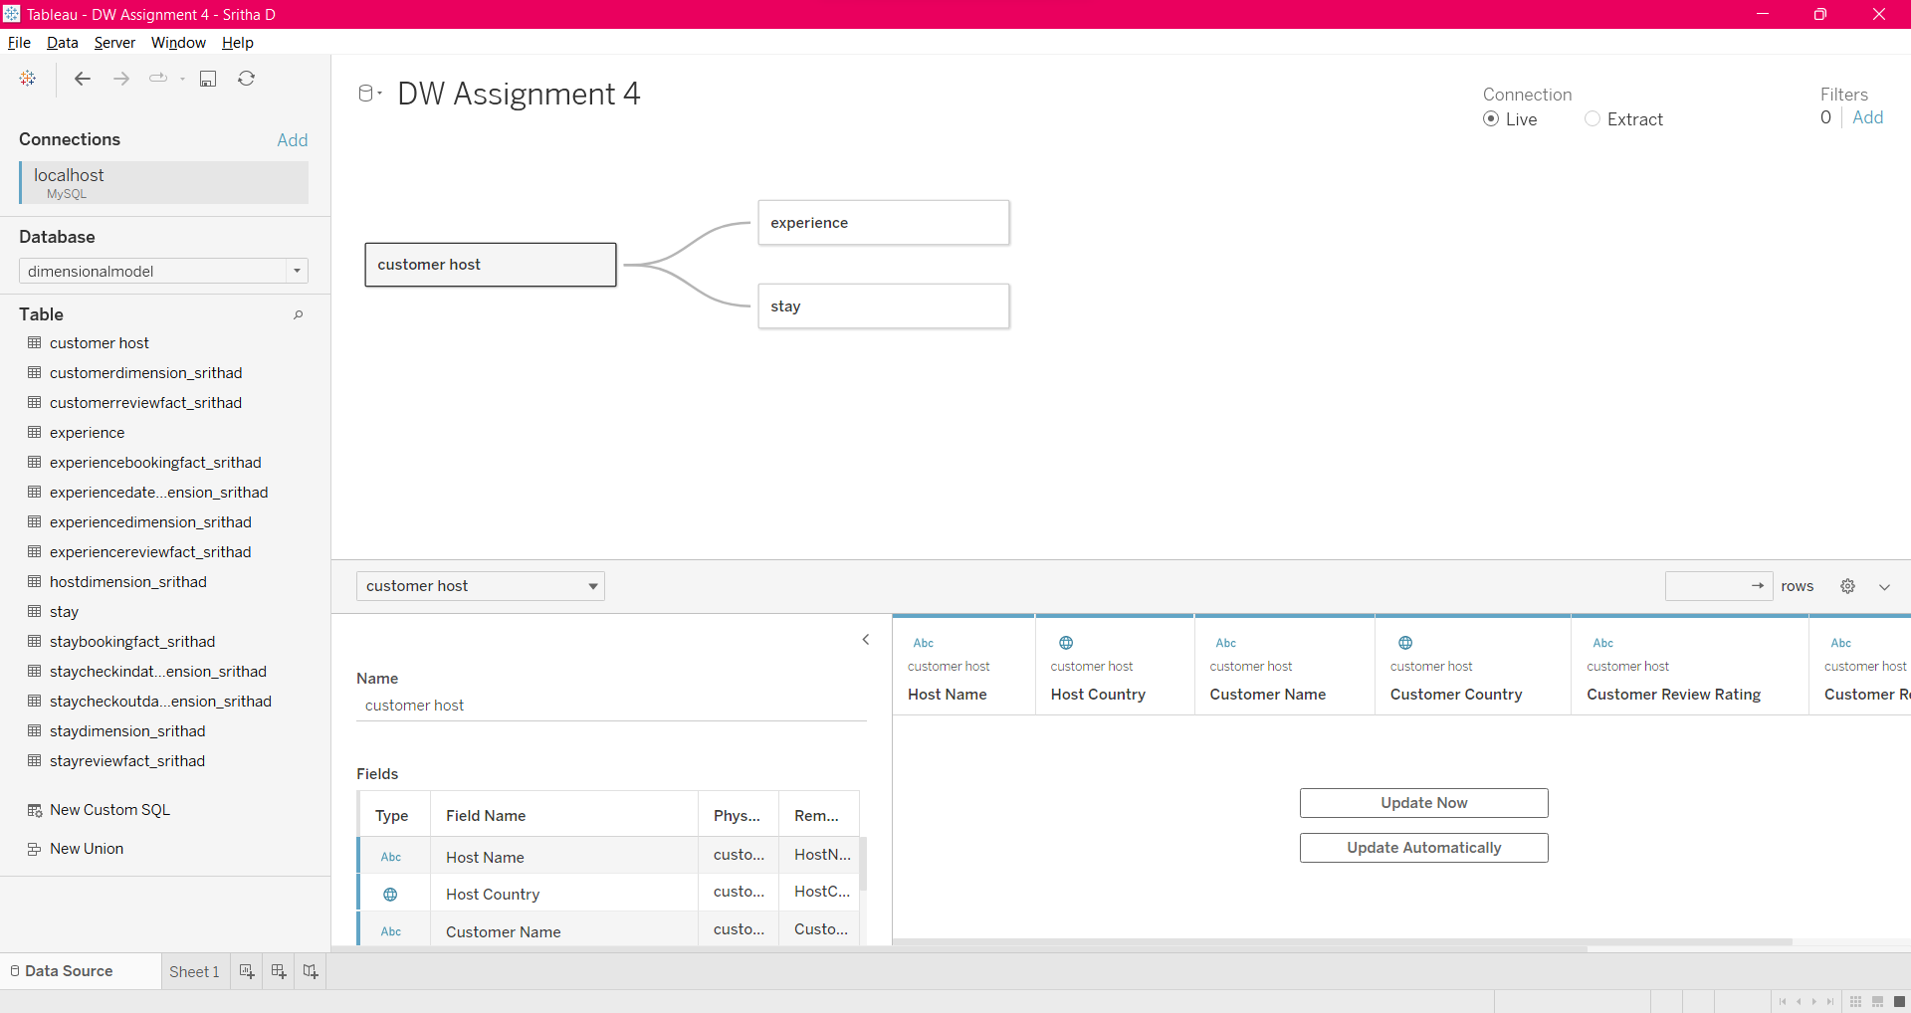

**Views:**

Stay View:

CREATE

ALGORITHM = UNDEFINED

DEFINER = `root`@`localhost`

SQL SECURITY DEFINER

VIEW `stay` AS

SELECT

`staydimension_srithad`.`StayID` AS `StayID`,

`staydimension_srithad`.`Stay_NumberofGuests` AS `Stay_NumberofGuests`,

`staydimension_srithad`.`Stay_Type` AS `Stay_Type`,

`staydimension_srithad`.`Stay_NumofBeds` AS `Stay_NumofBeds`,

`staydimension_srithad`.`Stay_NumofBaths` AS `Stay_NumofBaths`,

`staydimension_srithad`.`Stay_Pricepernight` AS `Stay_Pricepernight`,

`staydimension_srithad`.`Stay_Cleaningfees` AS `Stay_Cleaningfees`,

`staydimension_srithad`.`Stay_Cancellationoption` AS `Stay_Cancellationoption`,

`staydimension_srithad`.`Stay_Location` AS `Stay_Location`,

`stayreviewfact_srithad`.`StayReviewRating` AS `StayReviewRating`,

`stayreviewfact_srithad`.`StayReviewCount` AS `StayReviewCount`,

`staycheckindatedimension_srithad`.`StayCheckinDate` AS `StayCheckinDate`,

`staycheckoutdatedimension_srithad`.`StayCheckoutDate` AS `StayCheckoutDate`,

`customerdimension_srithad`.`CustomerID` AS `CustomerID`

FROM

((((((`customerdimension_srithad`

JOIN `stayreviewfact_srithad` ON ((`customerdimension_srithad`.`CustomerID` = `stayreviewfact_srithad`.`CustomerID`)))

JOIN `staybookingfact_srithad` ON ((`customerdimension_srithad`.`CustomerID` = `staybookingfact_srithad`.`CustomerID`)))

JOIN `hostdimension_srithad` ON ((`staybookingfact_srithad`.`HostID` = `hostdimension_srithad`.`HostID`)))

JOIN `staydimension_srithad` ON ((`staybookingfact_srithad`.`StayID` = `staydimension_srithad`.`StayID`)))

JOIN `staycheckindatedimension_srithad` ON ((`staybookingfact_srithad`.`StayCheckinDate` = `staycheckindatedimension_srithad`.`StayCheckinDate`)))

JOIN `staycheckoutdatedimension_srithad` ON ((`staybookingfact_srithad`.`StayCheckoutDate` = `staycheckoutdatedimension_srithad`.`StayCheckoutDate`)))

Experience View:

CREATE

ALGORITHM = UNDEFINED

DEFINER = `root`@`localhost`

SQL SECURITY DEFINER

VIEW `experience` AS

SELECT

`experiencedimension_srithad`.`ExperienceID` AS `ExperienceID`,

`experiencedimension_srithad`.`Experience_Location` AS `Experience_Location`,

`experiencedimension_srithad`.`Experience_DaysAvailable` AS `Experience_DaysAvailable`,

`experiencedimension_srithad`.`Experience_NumofGuests` AS `Experience_NumofGuests`,

`experiencedimension_srithad`.`Experience_Priceforexperience` AS `Experience_Priceforexperience`,

`experiencedimension_srithad`.`Experience_Type` AS `Experience_Type`,

`experiencedimension_srithad`.`Experience_TotalTime` AS `Experience_TotalTime`,

`experiencedimension_srithad`.`Experience_LanguageAvailable` AS `Experience_LanguageAvailable`,

`experiencedimension_srithad`.`Experience_isPrivateGroup` AS `Experience_isPrivateGroup`,

`experiencereviewfact_srithad`.`ExperienceReviewRating` AS `ExperienceReviewRating`,

`experiencereviewfact_srithad`.`ExperienceReviewCount` AS `ExperienceReviewCount`,

`experiencedatedimension_srithad`.`ExperienceDate` AS `ExperienceDate`,

`hostdimension_srithad`.`HostID` AS `HostID`

FROM

(((((`customerdimension_srithad`

JOIN `experiencereviewfact_srithad` ON ((`customerdimension_srithad`.`CustomerID` = `experiencereviewfact_srithad`.`CustomerID`)))

JOIN `experiencedimension_srithad` ON ((`experiencedimension_srithad`.`ExperienceID` = `experiencereviewfact_srithad`.`ExperienceID`)))

JOIN `experiencebookingfact_srithad` ON ((`experiencebookingfact_srithad`.`ExperienceID` = `experiencedimension_srithad`.`ExperienceID`)))

JOIN `experiencedatedimension_srithad` ON ((`experiencedatedimension_srithad`.`ExperienceDate` = `experiencebookingfact_srithad`.`ExperienceDate`)))

JOIN `hostdimension_srithad` ON ((`experiencebookingfact_srithad`.`HostID` = `hostdimension_srithad`.`HostID`)))

Customer – Host View:

CREATE

ALGORITHM = UNDEFINED

DEFINER = `root`@`localhost`

SQL SECURITY DEFINER

VIEW `customer host` AS

SELECT

`hostdimension_srithad`.`HostName` AS `HostName`,

`hostdimension_srithad`.`HostCountry` AS `HostCountry`,

`customerdimension_srithad`.`CustomerName` AS `CustomerName`,

`customerdimension_srithad`.`CustomerCountry` AS `CustomerCountry`,

`customerreviewfact_srithad`.`CustomerReviewRating` AS `CustomerReviewRating`,

`customerreviewfact_srithad`.`CustomerReviewCount` AS `CustomerReviewCount`,

`customerdimension_srithad`.`CustomerID` AS `CustomerID`,

`hostdimension_srithad`.`HostID` AS `HostID`

FROM

((`customerdimension_srithad`

JOIN `customerreviewfact_srithad` ON ((`customerreviewfact_srithad`.`CustomerID` = `customerdimension_srithad`.`CustomerID`)))

JOIN `hostdimension_srithad` ON ((`customerreviewfact_srithad`.`HostID` = `hostdimension_srithad`.`HostID`)))

I have then made some changes to the Sidebar as per how I want to show the visualizations.

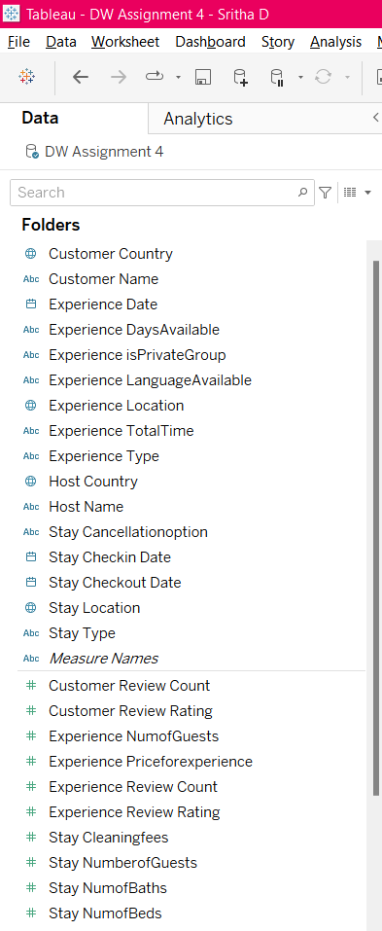 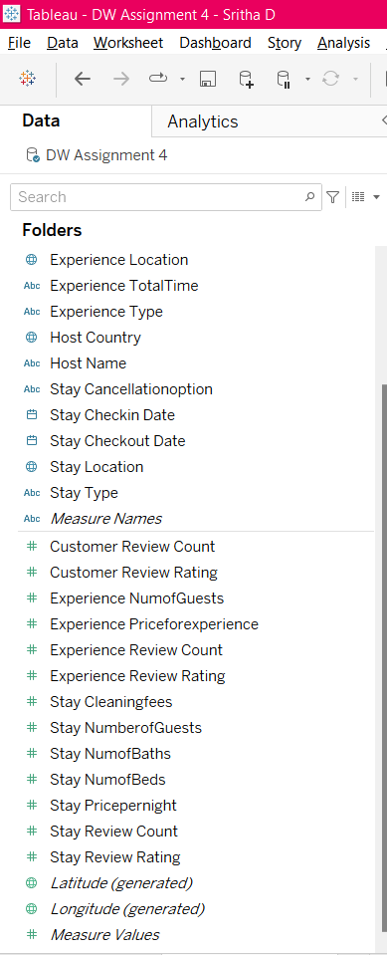

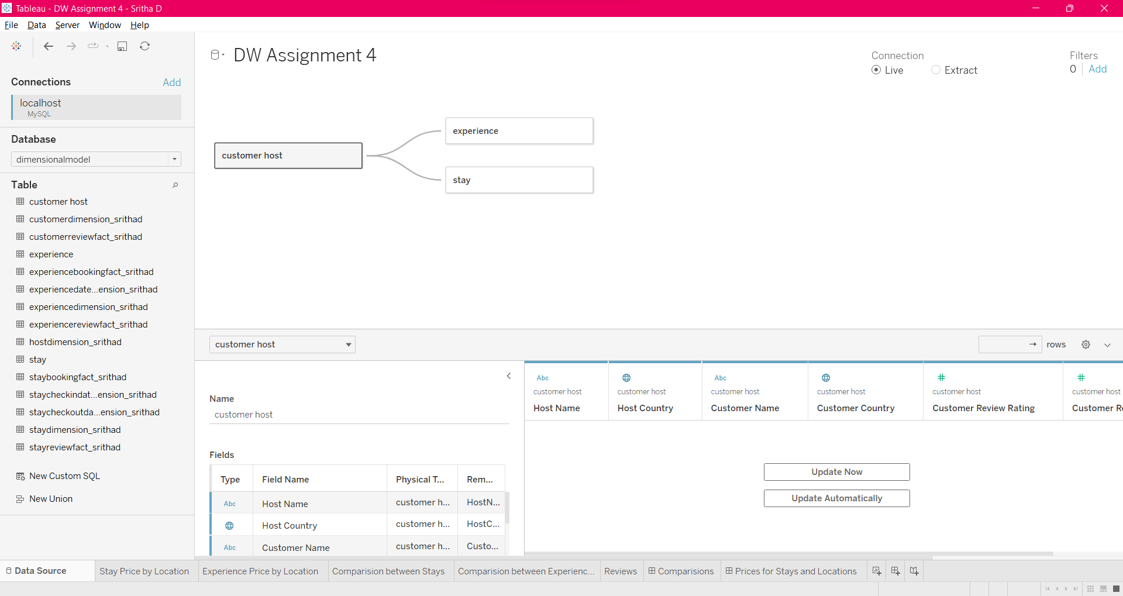

I have created a total of five sheets and two Dashboards.

Sheet: Stay Price by Location

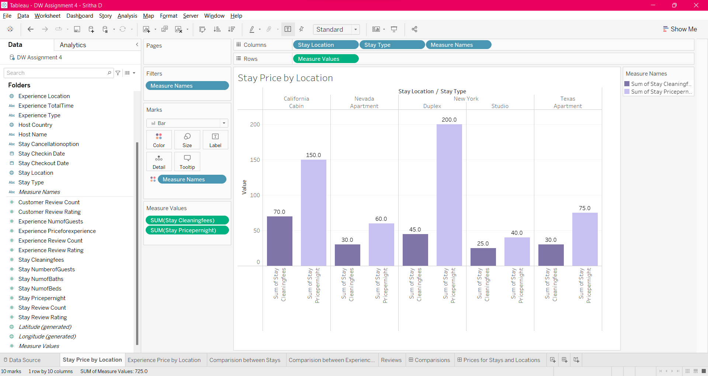

Sheet: Experience Price by Location

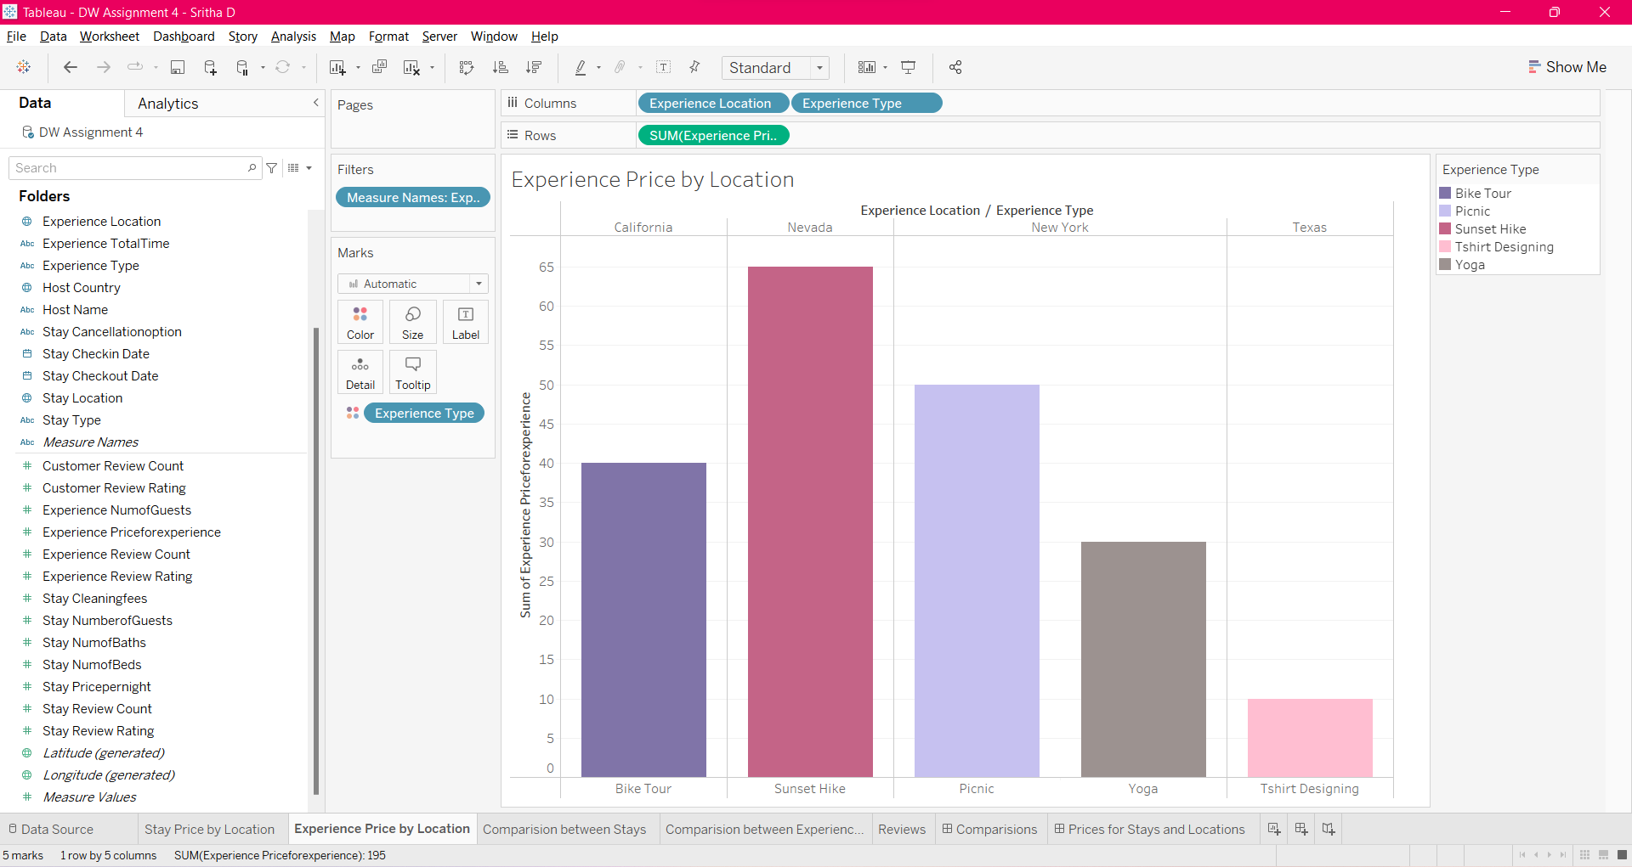

Sheet: Comparison between Stays

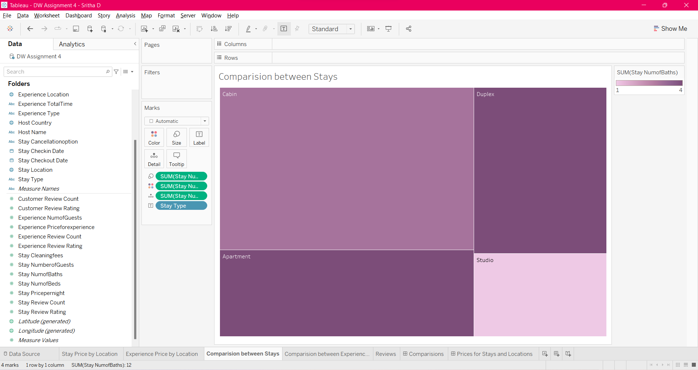

Sheet: Comparison between Experiences

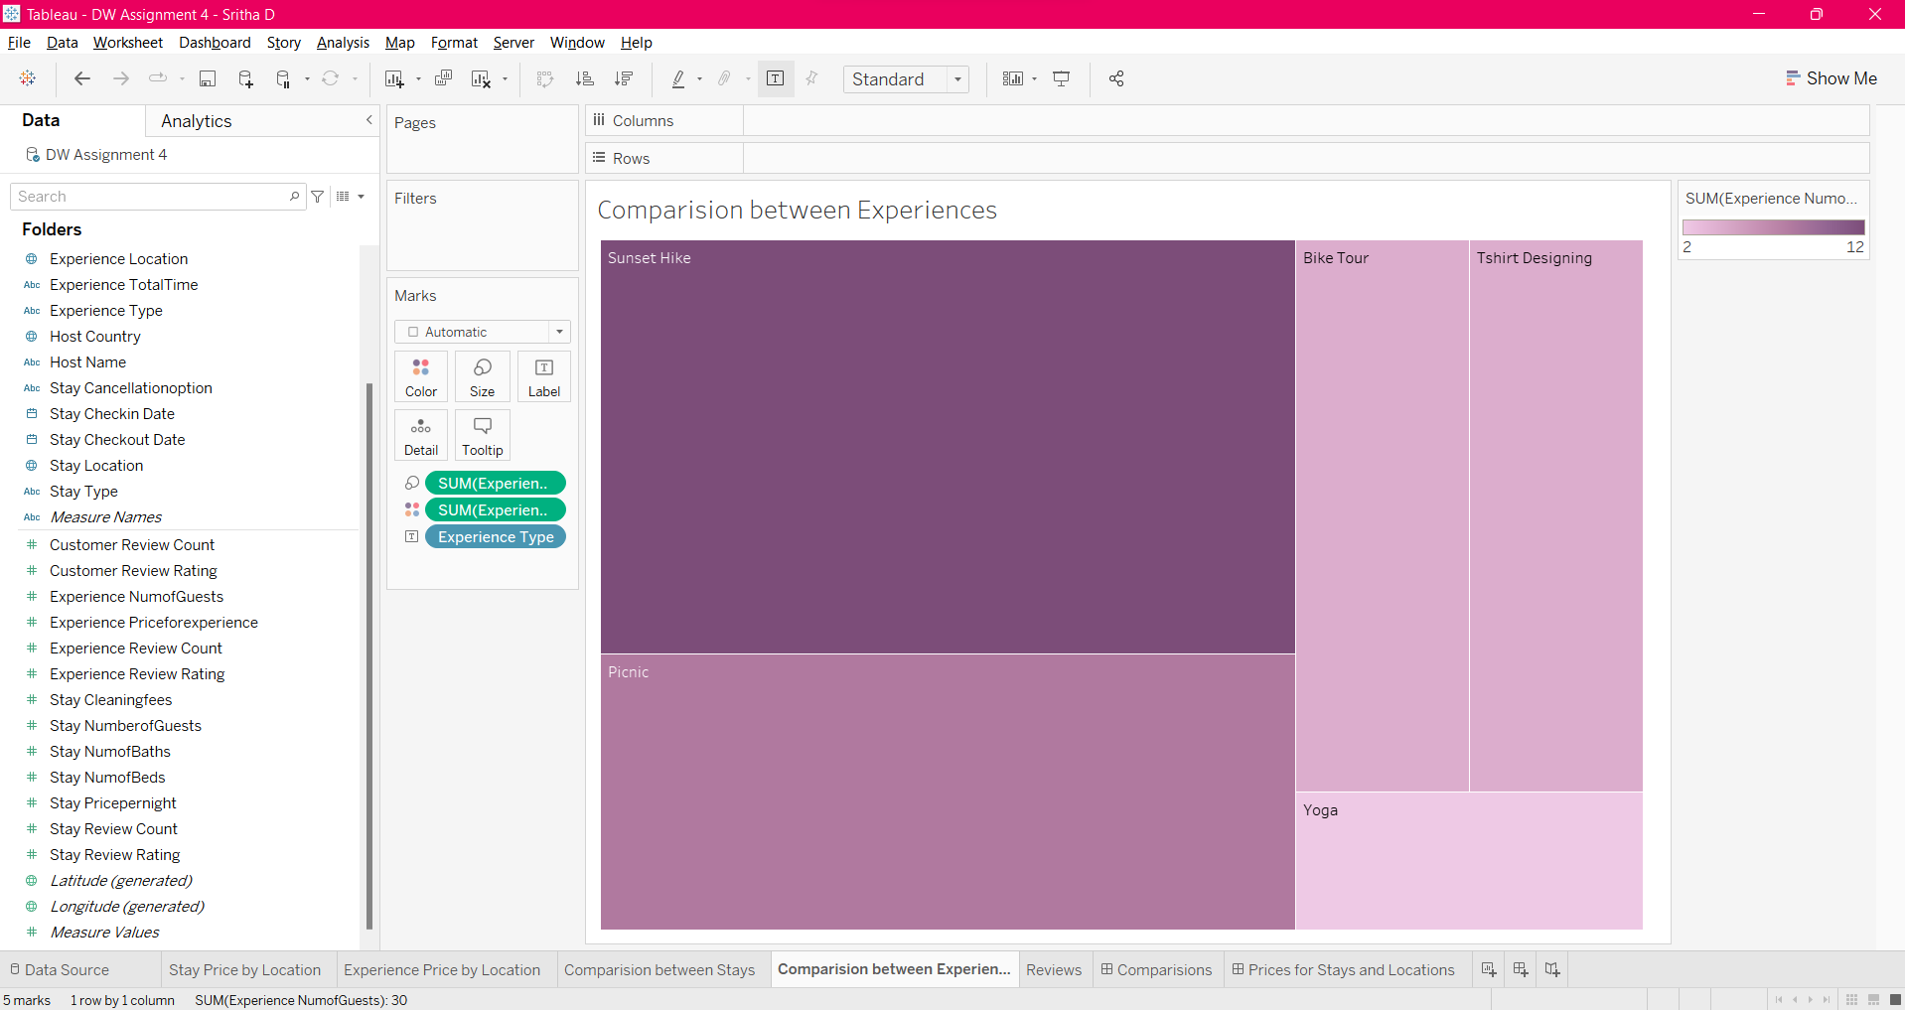

Sheet: Reviews by Month

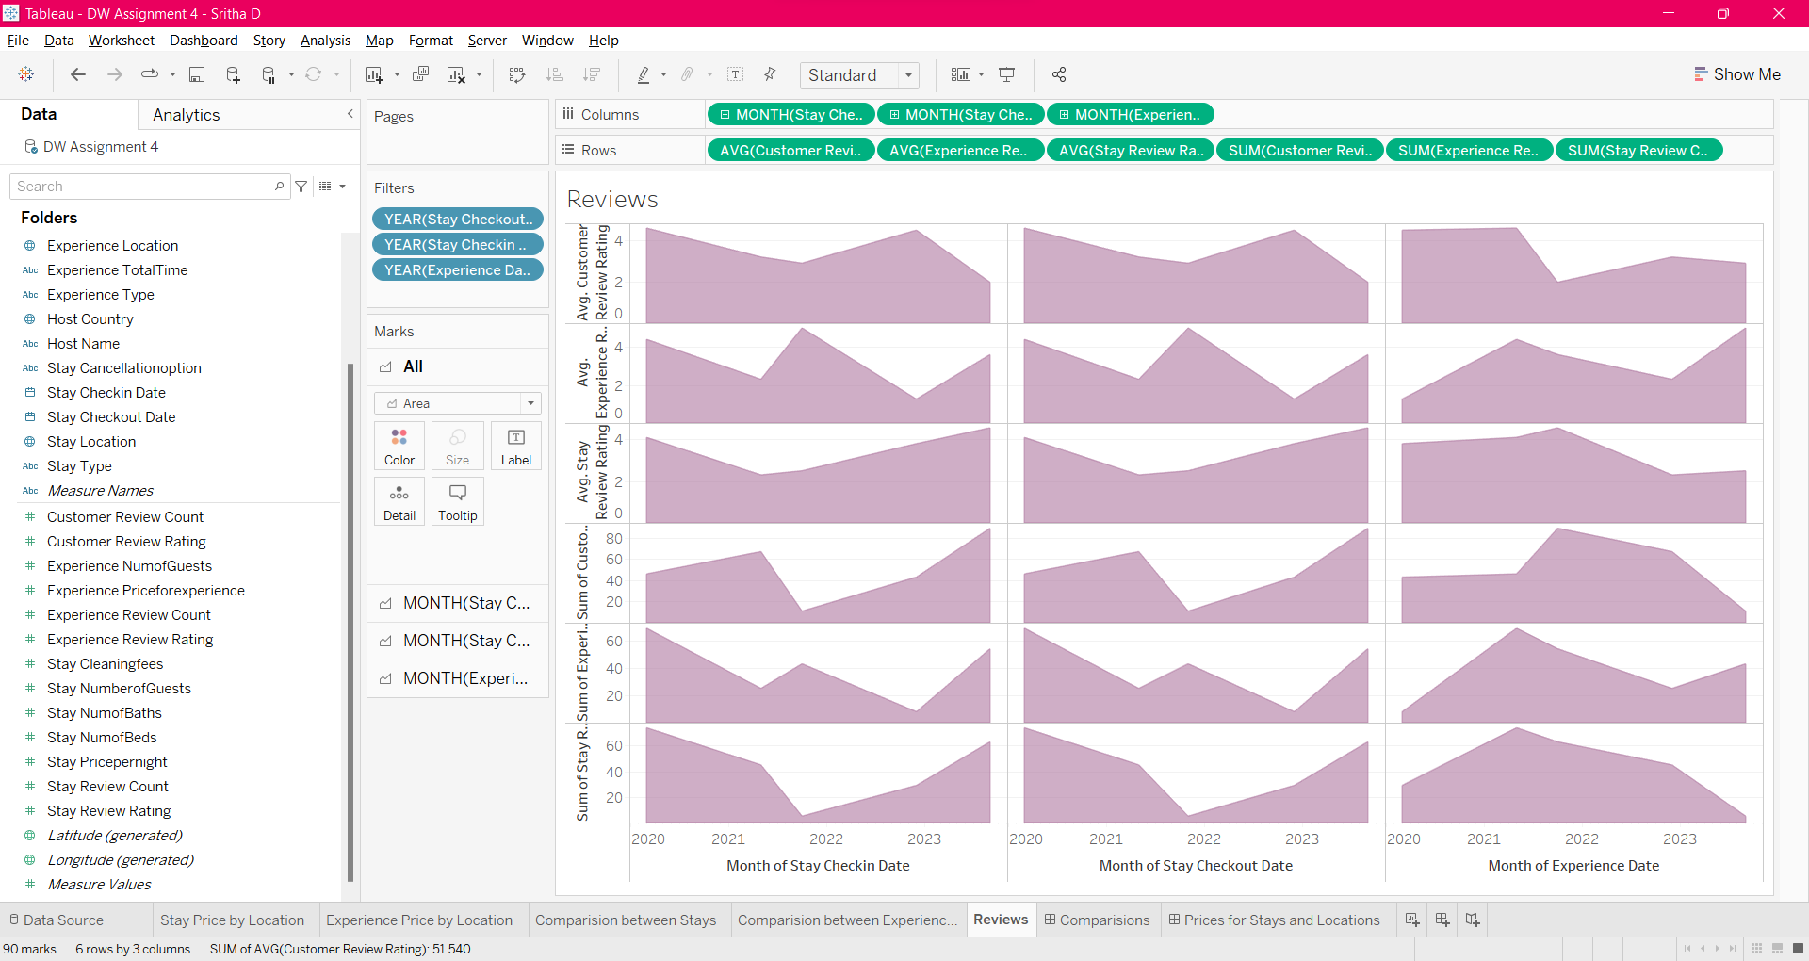

Dashboard: Comparisons

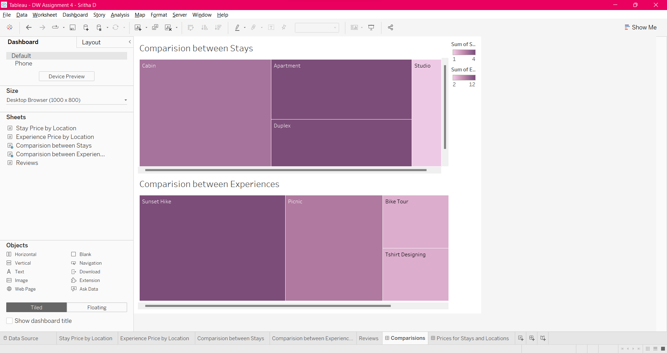

Dashboard: Prices for Stays and Locations

